Monthly Report for the month of May 2024
The Activities Conducted for the month of May are as follows:
THE GLOBAL ALUMNI MEET 2024:
The Global Alumni Meet 2024, on hybrid mode was organized by the IQAC of JSSLC in association with the JSSLC Alumni Association, Mysuru, on 11 -05-2024, by the President Dr. N Vani Shree and Secretary Mr. Pranav Kumar Nair of the JSSLC Alumni Association, Mysuru.
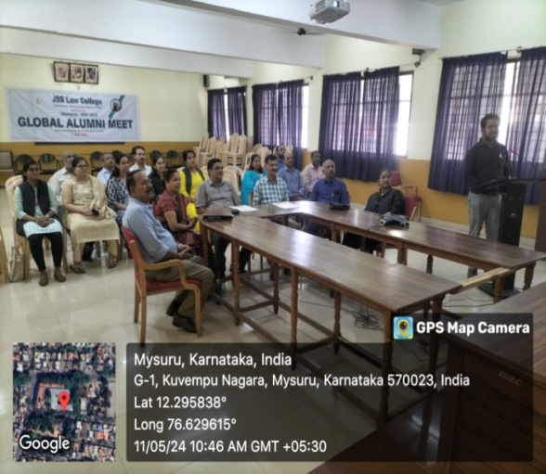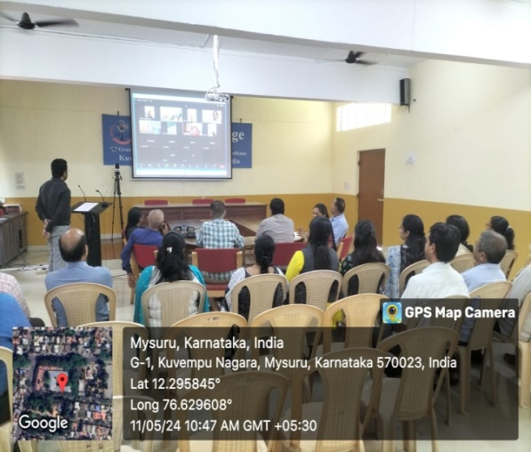
EXPO ON “BANKING BOUNDARIES: EXPLORING THE LAW AND PRACTICE”
The VI Semester students of BBA.LL.B (Hons.) along with the course teacher of Law of Banking Dr. N Vani Shree organized an Expo on “Banking Boundaries: Exploring the Law and Practice”, on 17 -05 - 2024, at 2.00pm as a part of the experiential learning and practical activity. The event focused on discussing and exploring the intricacies of Banking Law and Practices. This insightful session aims to delve into the complexities and nuances of banking law, providing a comprehensive understanding of its practical applications.
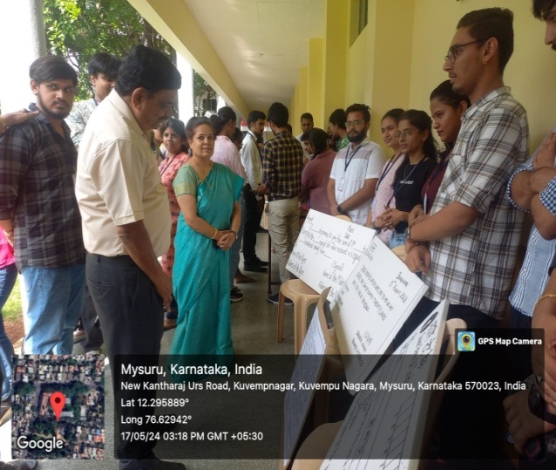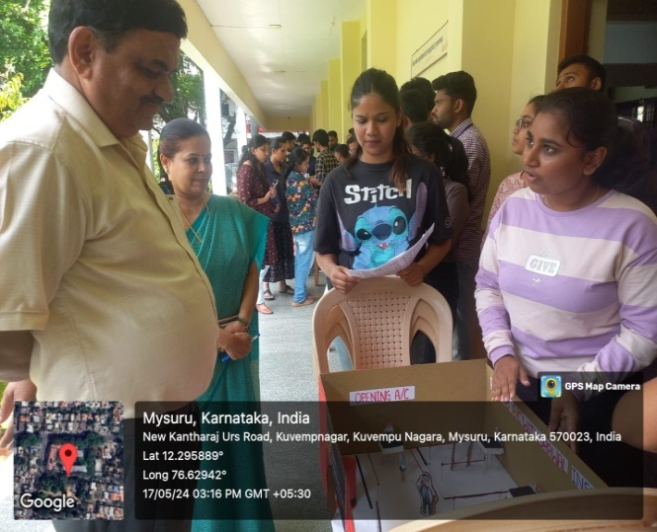

EXPO ON “THE COIN AND THE GAVEL: A BANKING PALETTE”
The VI Semester students of BA.LL.B (Hons) along with the course teacher of Law of Banking Dr. N Vani Shree organized an Expo on “The Coin and the Gavel: A Banking Palette”, on 17 -05- 2024, at 2.00pm as a part of the experiential learning and practical activity.

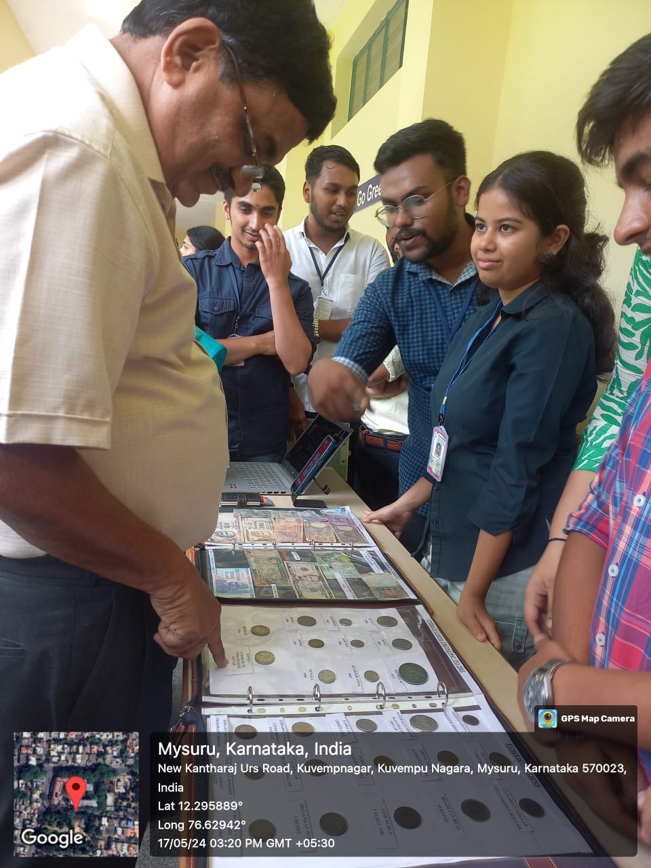
PARENTS’ MEET:
The Annual Parents' Meeting 2023-24 was held on 18-05-24, in the college Silver Jubilee Hall.
About 175 parents took part in the meeting. The event was coordinated by Smt. Nandini MS.
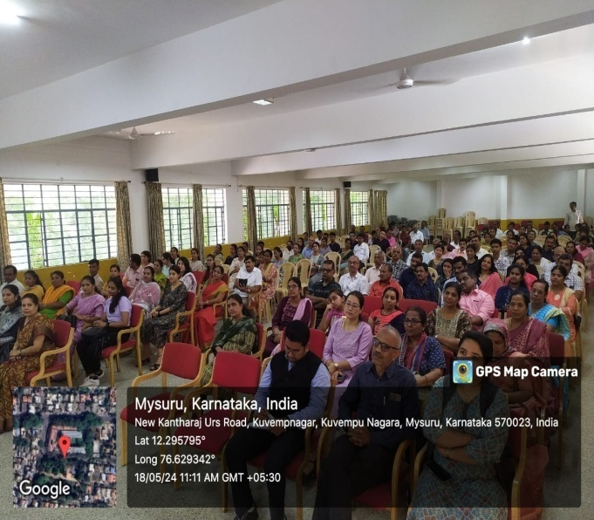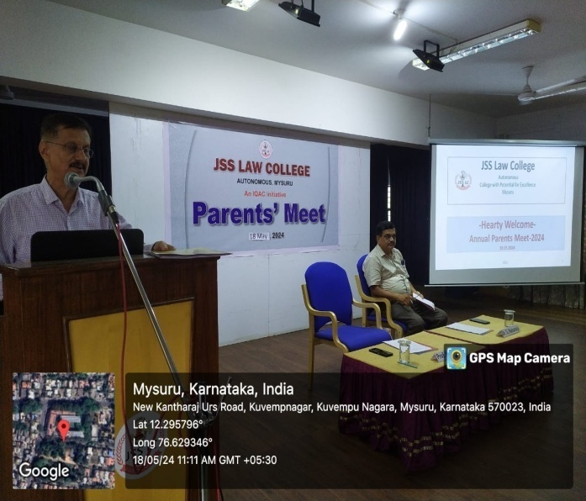

MUN ACTIVITIES:
MUN delegates have conquered the International MUN circuit at the Azimuth International Model United Nations Conference which was held at SAGE University Bhopal on 4th and 5th May 2024.
There were 448 participants across India. The following students won laurels :
1. Vrishab Yoganand of IV SEM BBA LLB won a Special Mention at the World Trade Organisation Representing the United Kingdom.
2. Mohammad Subhan of IV SEM BBA LLB Won Best Delegate at UNSC representing Palestine.

WORLD NO TOBACCO DAY (2024)
On 31-05-2024, an awareness programme was organised on World No Tobacco Day. World No Tobacco Day is observed on May 31st every year to raise awareness about the health risks associated with tobacco use and advocate for effective policies to reduce tobacco consumption globally. The Programme was co-ordinated by Mr. Pranav Kumar Nair, Assistant Professor in association with NSS Unit of JSS Law College. Mr. Pranav welcomed the attendees and introduced the Chief Guest Dr. Anil Sangli. Prof K.S Suresh, Chief Executive; Dr. N. Vanishree, Chairman, P.G. Dept. of Law; Teaching & Non-Teaching staff and Students were present.
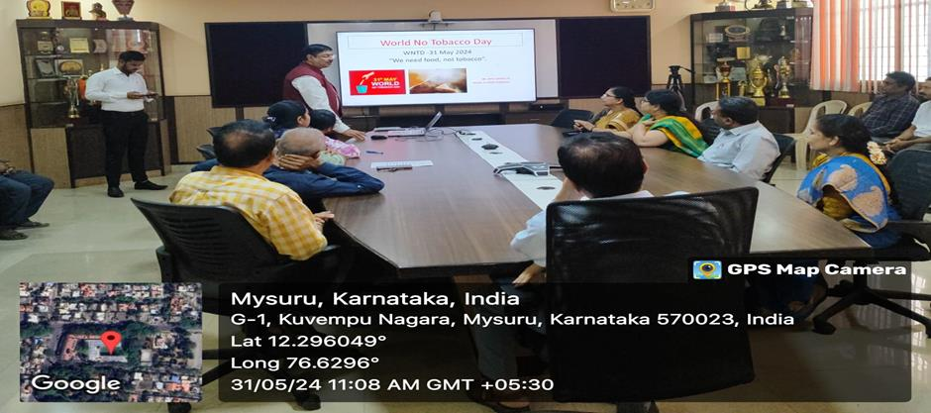
OTHER COLLEGE ACTIVITIES:
- The Short term course on Art of Contract Drafting was successfully completed after the evaluation process on 17 -05- 2024, at 11.30am. The Expert Resource person Mr. Karthik Santhakumar, the Course Co-ordinator Dr. N Vani Shree and Student Coordinators assisted in the same.
- Dr. S. Nataraju, Principal, JSSLC was accorded a heartfelt farewell on attaining the age of superannuation by the college staff on the 31 -05- 2024. Ms. Harshitha Assistant Professor of Political Science was also given a send-off by the College. Dr. N Vani Shree took charge as the new Principal of the college from 1 -06-2024.
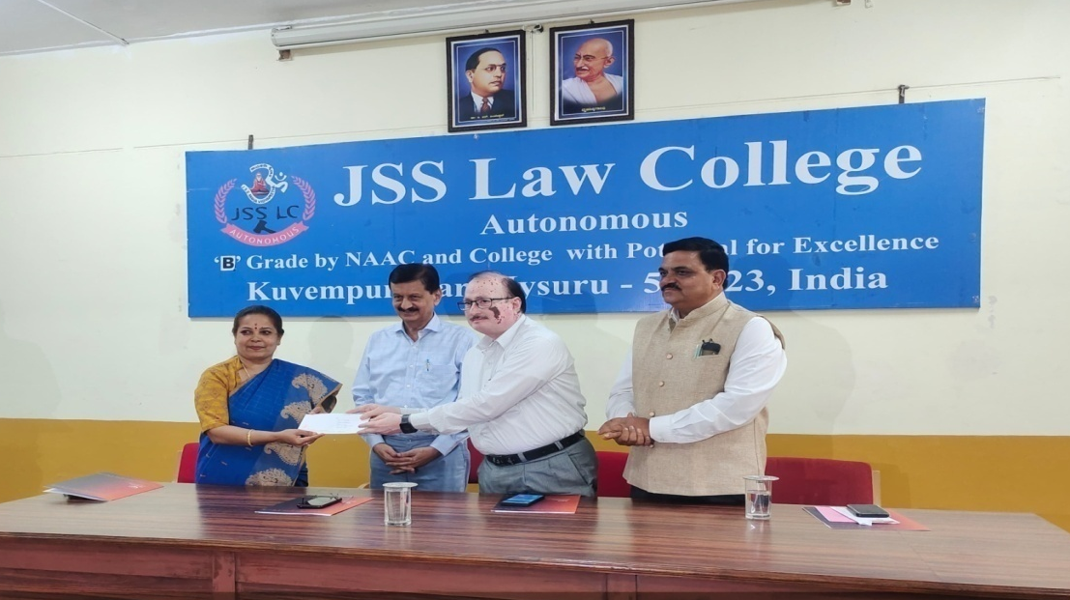

- The Chairperson of PG Department of Studies in Law Dr. N Vani Shree along with the other PG faculty members convened the BOS (PG) Meeting on the 9 -05- 2024, in the Board room of the college.
- The Student Academic Council meeting was held on 3-05.2024.
- The Board of Studies (Under Graduate) – BOS UG meeting was convened on 4-5-2024.
- The Mentor-Mentees Cell meeting was held on 8-5-2024.
- Annual NSS camp was organized by JSS Law College at Sajjehundi Village, Mysore Taluk and District from 28.04.2024 to 04.05.2024

Teacher’s Participation:
- Smt. Asmathunnisa.G Participated as a guest at NSS held at Sajjehundi Village, Hollenarasapura on 2 – 05- 2024, and delivered an awareness talk on “Importance of Girl Child Education “at 6:00pm.
- Smt Asmathunnisa.G Participated in a National level webinar On Weaponization Of Space and Outer Space Law organised by legal voice on 2-05-2024(Online mode), organised by the Legal Voice.
- Smt. Asmathunnisa.G Participated in ‘Two Day Certificate Course on Interface between Intellectual Property and Environmental Law ‘Organised on 11th and 12th of May 2024, organised by the Legal voice.
- Smt. Asmathunnisa.G Participated in the Online webinar “Data Privacy Law in the Age of AI” , organised by the school of Law, Mahindra University, Hyderabad on 4 -05-2024.

NCC ACTIVITIES:
- The JSSLC NCC cadets, Cdt.Sgt. Abijith and Cdt.. Veeresh went for flying which is an adventurous activity of the Air Wing on 1 -05- 2024, at the Mandakalli Airport, Mysuru.
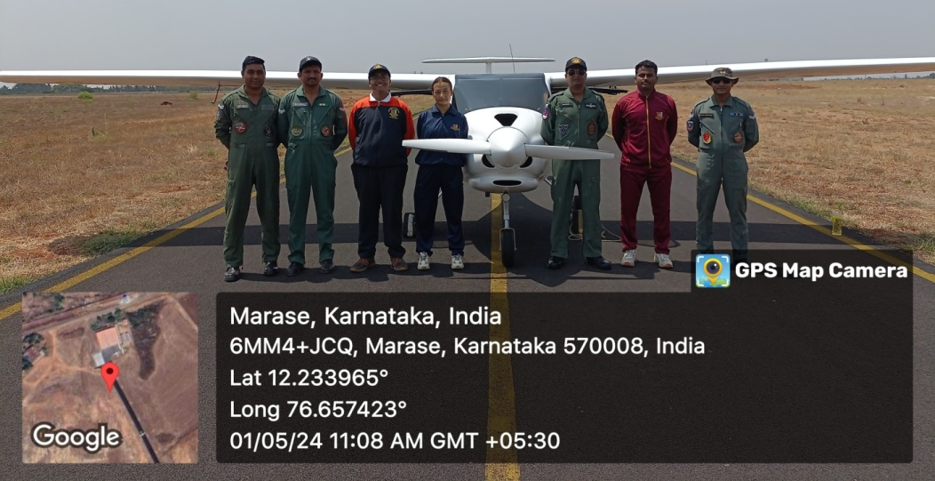
- The JSSLC NCC cadets went for flying which is an adventurous activity of the Air Wing on 20- 05- 2024, at the Mandakalli Airport, Mysuru.

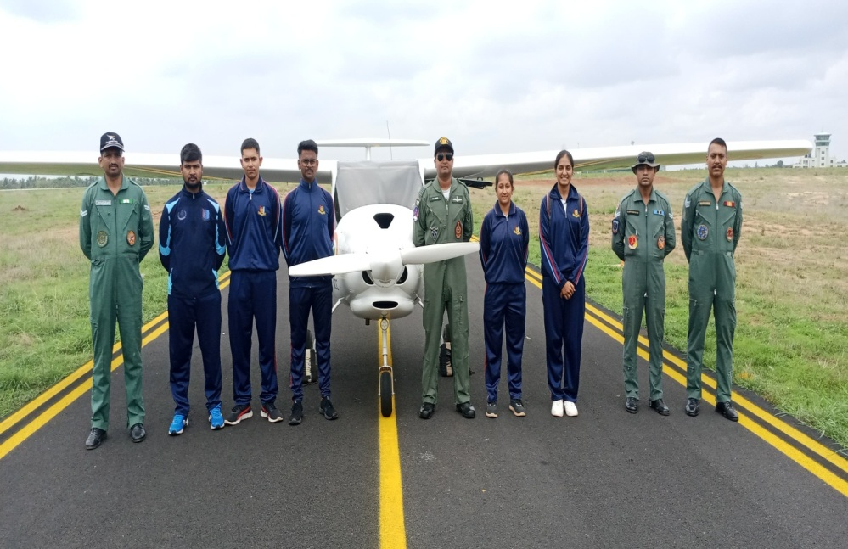
- The JSSLC NCC cadets went for flying which is an adventurous activity of the Air Wing on 21 -05- 2024, at the Mandakalli Airport, Mysuru.
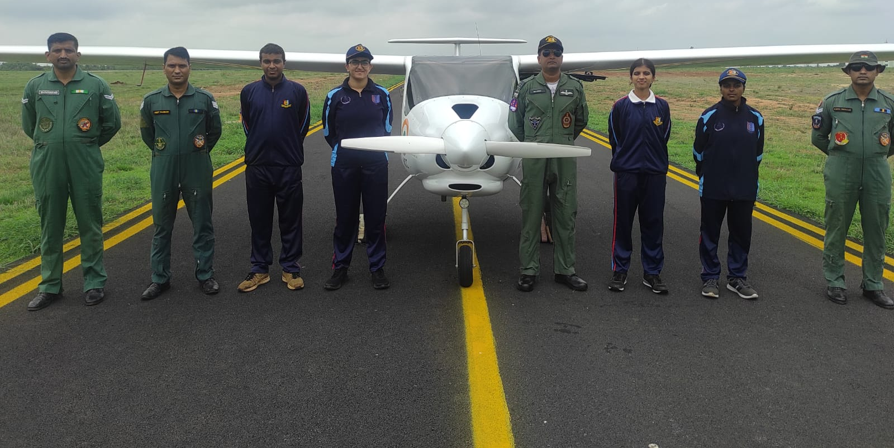
- The JSSLC NCC cadets along with ANO Flt Lt. Dr. N Vani Shree went for flying which is an adventurous activity of the Air Wing on 27-05- 2024, at the Mandakalli Airport, Mysuru.
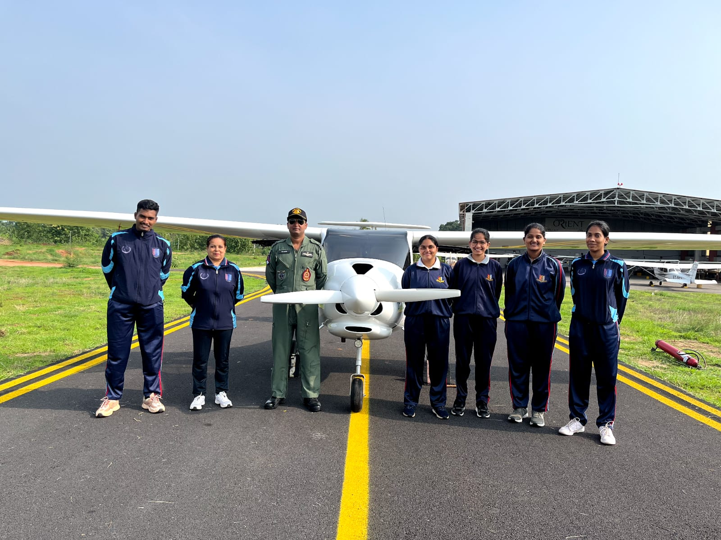

- Flt Lt Dr. N Vani Shree attended the ANOs Conference in connection with Annual Training Camp/Enrolment/Training on 22 -05- 2024, at 12.30pm in the 4 Kar Air NCC Unit premises at Naidunagara, Mysuru.
- Flt Lt Dr. N Vani Shree was felicitated on 27 -05- 2024, at 11.30am at the Quorum Hotel, Vinobha Road, Mysuru, by the NCC cadets of JSSLC for her commendable services in the NCC from 2012 till date, as the services of her as an ANO gets relinquished on the 31 -05- 2024.
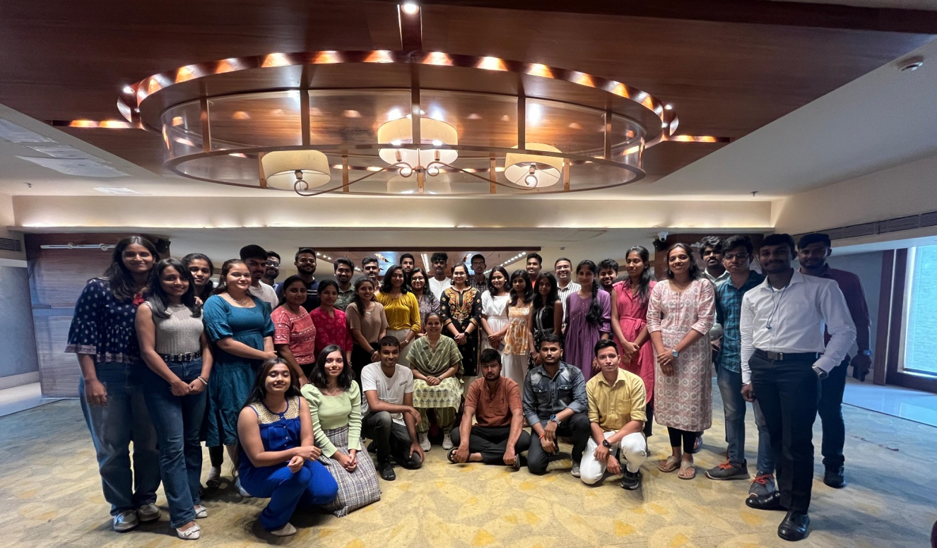

HOSTEL COMMITTEE ACTIVITIES:
A State level essay competition was organised by the Hostel Committee on the topic "Women from Home maker to parliament a struggle for success" and on “Role of Women as a single Parent in the present scenario" the prizes are as follows:
1st Place -Yashika Sharma of 4 yr MBBS JSS Medical college,
2nd Place Sania Sathish B.Sc, JSS AHER, Mysuru, and
3rd Place Devika CR 1 yr BA LLB from Vidyavardhaka Law College, Mysuru, the prizes were distributed during the Hostel Day which was held on 17 May 2024.

The Hostel day was held on 17 -o5- 2024, Dr. Sridevi Shinthri, Faculty ATI, Mysuru was the chief Guest and addressed the hostelites. Dr. Nataraju S Principal, staff and students were present.

