Monthly Report for the month of March 2024
The Activities Conducted for the month of March are as follows:

Placement cell activity:
Career Guidance & Placement Cell had organized One day Workshop On "Art of Resume Writing" by Sri. Karthik SanthaKumar Individual Counsel, Corporate Legal on 01-03-2024. The program was chaired by Dr. N Vanishree Assistant Professor and M. C Usha Rani Assistant Professor, JSS Law College Mysuru. The Program was coordinated by Smt. Tejaswini M Placement Cell Coordinator.

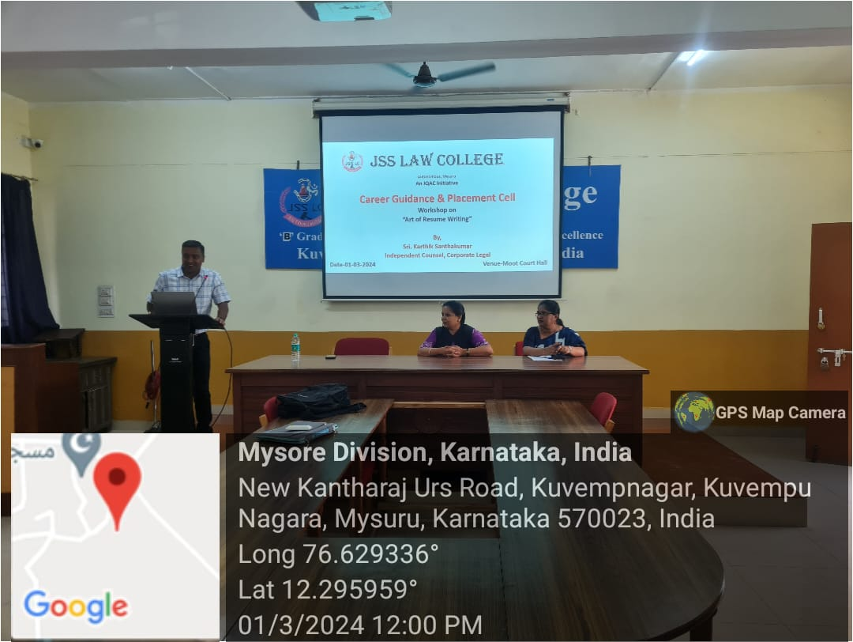

One day Symposium:
One day Symposium on exploring the interplay between social sciences and law was organised by the department of Sociology, Economics and Political science on 1 -3- 2024. The programme was inaugurated by the Chief Guest and key speaker Prof.J. Somshekar, Director of Ambedkar studies and Research centre, University of Mysore. The resource person spoke on the topic “One Nation and One Election: Pros and Cons.” Dr. N Vani Shree presided over the Symposium. 110 Students of II Semester BA LLB and IV Semester BA LLB participated in the symposium.

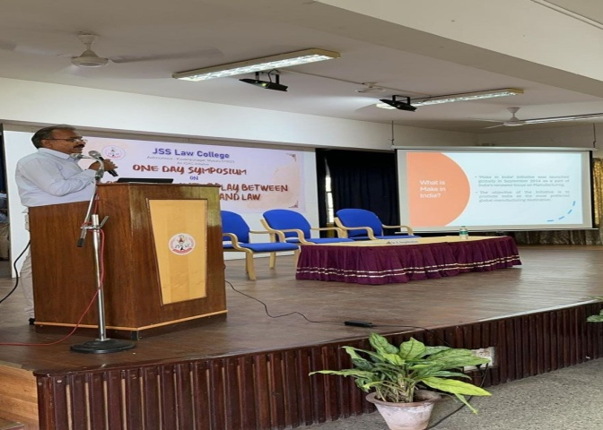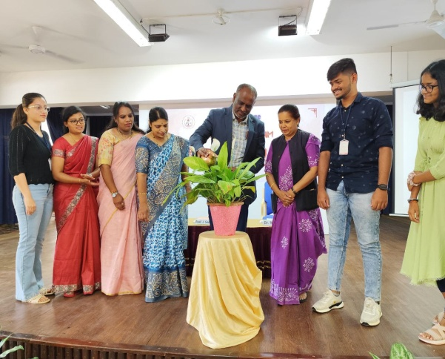

21ST SURANA AND SURANA NATIONAL CORPORATE LAW MOOT COMPETITION & NATIONAL JUDGEMENT WRITING COMPETITION 2024
JSS Law College (Autonomous), Mysuru in association with Surana and Surana International Attorneys, Chennai had organized the 21stSurana and Surana National Corporate Law Moot Competition & National Judgement Writing Competition 2024 from 22nd to 24th March 2024. The event saw active participation from 18 colleges across the country.
The competition was inaugurated on 22-03-2024 at JSS Law College (Autonomous), Mysuru by Prof. (Dr.) S. Surya Prakash, Vice Chancellor, NLIU, Bhopal, presided by Prof. (Dr.) V Vijaya Kumar, Former Vice Chancellor, NLIU, Bhopal.

The Final rounds commenced with five judge bench comprising of Hon’ble Justice. B.S. Patil (Lokayukta, State of Karnataka), Smt. S V Gowramma (Presiding Officer, DRT II, Bengaluru), Sri. G Shivadass (Senior Advocate, Bengaluru), Sri. Achuta (Chartered Accountant, Mysore) and Sri. Karthik Ranghanathan (Standing Counsel, Madras High Court, Chennai).

The valedictory programme was held in the Silver Jubilee Hall which commenced at 5:30pm. The valedictory address was given by Hon’ble Justice. B.S. Patil, Lokayukta, State of Karnataka) presided by Dr. C G Bestsurmath, Executive Secretary, JSSMVP, Mysuru.
Institute of Law, Nirma University Gujarat were the winners
GOVERNMENT LAW College, MUMBAI were the runners.

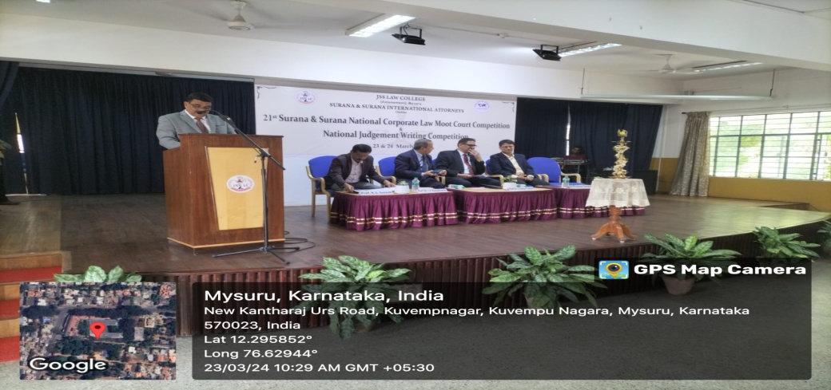

One Day National Seminar:
One Day National Seminar on “ARTIFICIAL INTELLIGENCE AND IPR- A PARADIGMATIC SHIFT & FUTURE IMPLICATIONS” was held in the college on 30.03.2024. Dr. Sairam Bhat Professor of Law, NLSUI, Bangalore inaugurated the National Seminar. Dr. Savitha L. Patil, Dr Gagan K and Dr. S. Nataraju Principal were also present.
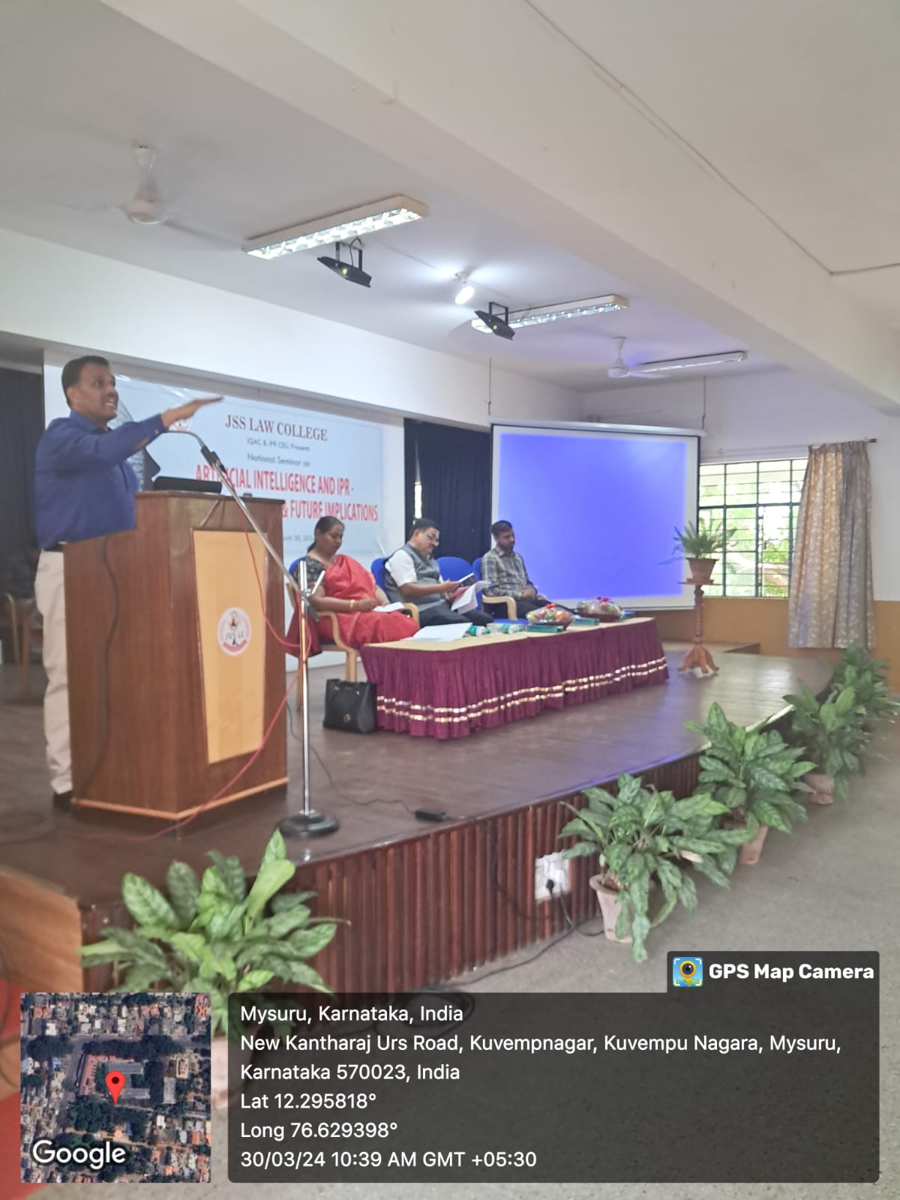

Student’s Achievements:
Moot Activities:
- In the 19th Nani Palkhivala Memorial National Tax Moot Court Competition, 2024 held at
SASTRA University
1. Hemica Ponnamma (S1)- VIII semester B.A.LLB
2. Neeraja Rajesh (S2)- X semester B.B.A.LLB
3. P G Lisha (R) - VI semester B.B.A.LLB

Were adjudged the WINNERS receiving a cash prize of Rs.50,000

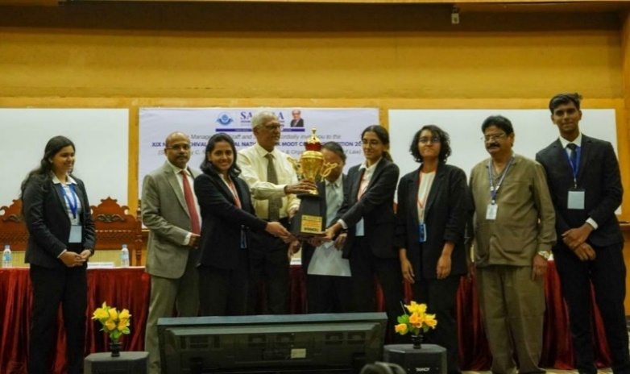

- Dr. Ambedkar Government Law College, Puducherry under the aegis of Ministry Of Consumer Affairs, Food and Public Distribution, Government of India had organized 47th All India Moot Court Competition on Consumer Law from 8th to 10th March 2024 wherein-
- Amoolya N Prasad- VIII Sem B.A.LLB
- Nikita Susan Eapen- VIII Sem B.A.LLB
- Rohan V Gangadkar- VI Sem B.A.LLB

Were adjudged the WINNERS receiving cash prize of Rs.50, 000 and Rohan V Gangadkar was declared the Best Researcher receiving a cash prize of Rs.5000. 55 teams from all over India participated and the winners were felicitated by Hon'ble Mr. Justice G.R. Swaminathan, Hon'ble Mr. Justice Sunder Mohan, Prof.Srikrishna Deva Rao (Vice- Chancellor, NALSAR, Hyderabad)

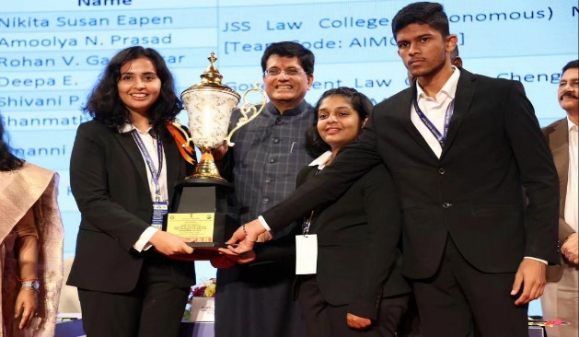
Department of Consumer Affairs under Ministry of Consumer Affairs, Food and Public Distribution, Government of India on the occasion of World Consumer Rights Day 2024 felicitated the WINNERS and the BEST LEGAL RESEARCHER of the All India Moot Court Competition on Consumer Law conducted by Dr.Ambedkar Government Law College, Puducherry.
They were felicitated by Hon'ble Mr. PiyushGoyal (Union Minister of Consumer Affairs), Bharat HaranslalKhera(Addl, secretary, DCOA), Shantmanu (ASAFA,MOCA, F&PD),NidhiKhare (OSD, DOCA), Rohit Kumar Singh(OSD, DOCA) and Anup Mishra (Joint Secretary, DCOA) on 15th March 2024 at Thakur College of Engineering and Technology in Mumbai.

- Narsee Monjee Institute of Management Studies, School of Law, situated at Bannerghatta,Bengaluru, Justice CK Thakkar National Moot and Mediation Competition was held
from 2-2-24 to 4-2-24.
The team wonthe following prizes:
1. Best Speaker - Ananya N of VIII sem (Cash prize of ₹8,500)
2. Best Mediator - R K Pooja VI sem (Cash Prize of ₹8,500)
3. Runner-up Mediating team. (Cash Prize of ₹15,000).

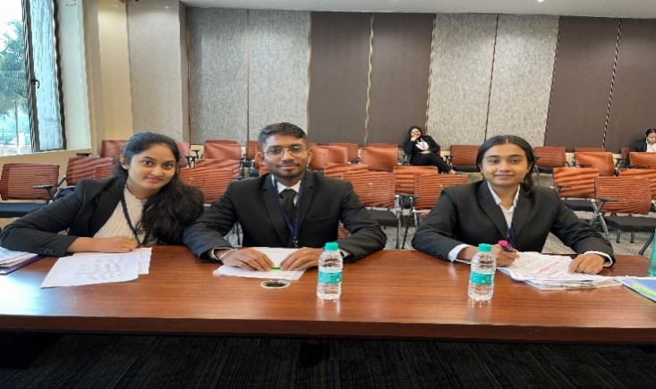
- Xavier Institute of Management and Entrepreneurship (XIME) conducted the Maria Philip Future Leaders Debate Competition, 2023-24 across South India and our college students
- Nikita Susan Eapen- VIII SemB.A.LLB (Hons.)
- Ananya V- VI SemB.B.A.LLB (Hons.)
were qualified for the State Level held on 9th February 2024 at XIME, Bangalore. They were adjudged as the Runners Up and awarded a cash prize of Rs. 15000.
Our college has won every year and this is the 3 consecutive year.

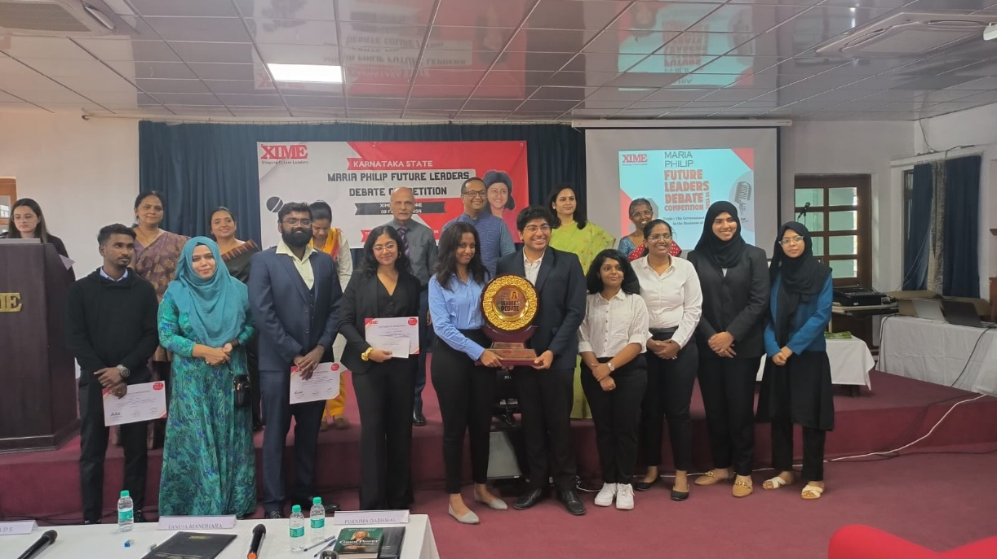

- Rahul , Anagha Bharadwaj and Surya V Somasundaram of VIII semester BBA LLB attended the 9th Annual SRM National Moot Court Competition held at SRM School of Law in Tamil Nadu on Artificial Intelligence and Intellectual Property Rights (IPR) held from March 14th to 16th 2024.

Practical visits to:
- SPORTS AUTHORITY OF INDIA BANGALORE:
A practical visit to SAI Bangalore (sports authority of India) was organized by 3rd year BA and BBA LLB of the College guided by Ms. Asmathunnisa G on 16th March 2024. 53 BBA LLB students and 58 BA LLB students interacted with eminent sports personalities to make it useful for the subject Sports law. Industrial visit was carried out for enhancing practical and industrial knowledge.
- FORENSIC MEDICINE & TOXICOLOGY LABORATORY:
Smt. Sheela Ganesh, Course Teacher – Sociology III (Social Psychology) accompanied by Smt. Soujanya Kumar, Faculty, (under IQAC) arranged the Forensic Medicine & Toxicology Laboratory visit to Department of Forensic Medicine and Toxicology, JSS Medical College, Mysuru, on 05.03.2024 for an experiential learning activity for IV Semester B.A., LL.B students (58 students).
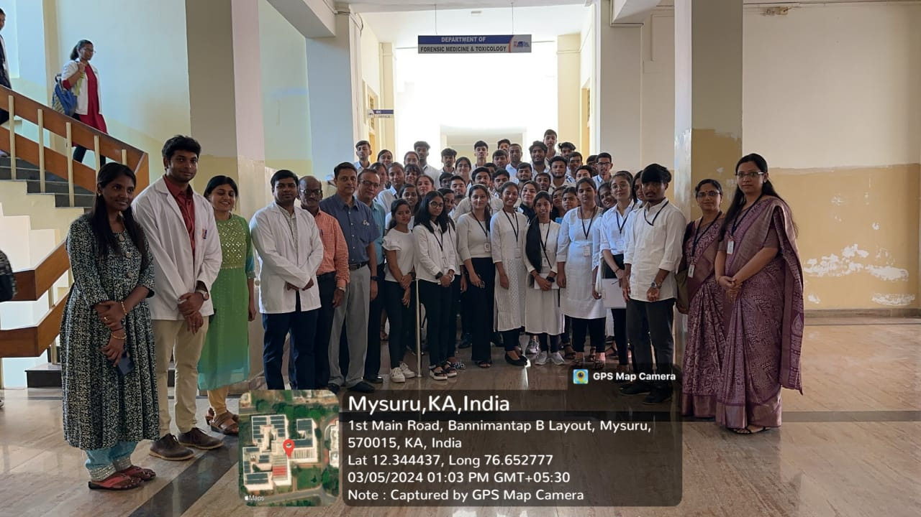
- JAIL VISIT:
Smt. Sheela Ganesh, Course Teacher – Sociology III (Social Psychology) accompanied by Smt. Swathi Sharma, Faculty, (under IQAC) arranged the Jail Visit to Central Prison, Mysuru on 06.03.2024 for an experiential learning activity for IV Semester B.A., LL.B students (58 students).
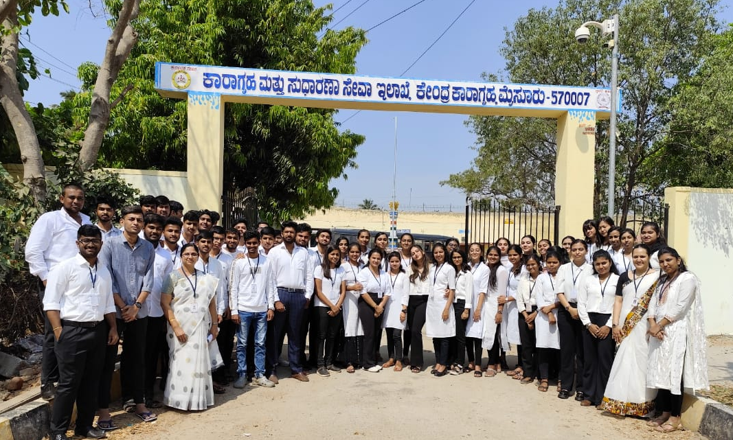
Special Lecture Programme:
- Smt. Sheela Ganesh, Course Teacher – Law & Agriculture, (under IQAC) arranged a special lecture on the topic ‘Globalisation and Agricultural Trends’ by inviting Prof.K. C. Basavaraju, Retired Professor of Economics, University of Mysore, Mysuru at the Silver Jubilee Hall on 03.03.2024 at 2.30pm and nearly 110 students from VI Semester B.A., LL.B and B.B.A., LL.B attended the special lecture. The special lecture was intended bring the following learning outcomes: a) To know the progress and process of changes in agricultural scenario, b) to relate the impact of WTO on agriculture – globally and at national level, c) to analyse and appraise the agricultural trends at national level, Five Year Plans, Policies, GDP etc.

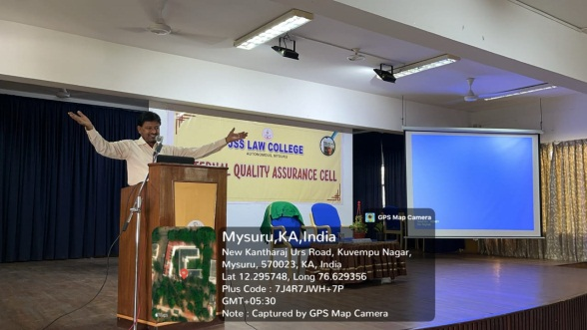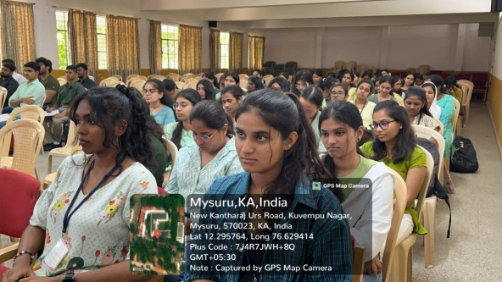
Women’s Day Celebration:
As a part of IQAC initiatives, the International Women’s Day was organised by the college in association with the JSSLC Women’s Cell, held on 12th March 2024 at the JSSLC Silver Jubilee Hall. This programme began with the inauguration by lighting the lamp by the guest, Smt. Susheela Kote (Asha Worker) H.D. Kote Tq, D.B. Guppe. The contributions made by her to the forest tribal’s of D.B. Kuppe were briefed through video clipping. She also shared her experiences as a social worker. Later she was felicitated by the Principal and Staff. This programme was presided by the Principal Dr.S.Nataraju. Dr. Vanishree faculty, the staff and the students were present on the occasion and other members of women’s organisation were also present in the programme. This programme was organised by Smt. K.S. Poornima, Asst.Prof JSS Law College, Mysuru.

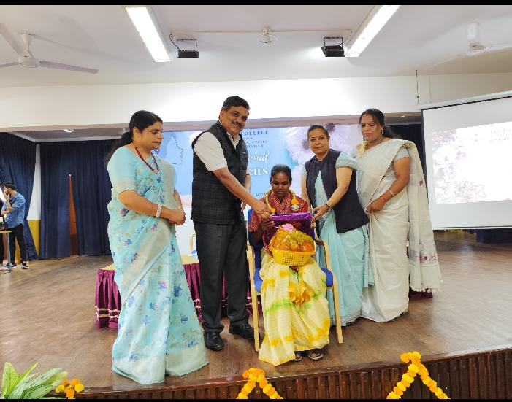

Teacher’s Achievements/Participation:
- Smt. Nandini M S has contributed a poem titled “Lethal Silence" for the anthology "Swallowed Words" published by Cloud of Thoughts publication under ISBN 978-81-971102-3-8.
- Smt. Soujanya G K (Co-authored) Ms. Amoolya N Prasad of VIII Semester B.A., LL.B presented research paper ‘The Intersection of AI-Created Art and Music with Intellectual Property Rights in India’ during the National Seminar on ‘Artificial Intelligence and IPR – Paradigmatic Shift & Future Implications’, organised by IQAC- JSS Law College, Autonomous, Mysuru on 30.03.2024.
- Smt. Sheela Ganesh participated in the One Week National Level Online Faculty Development Program on Outcome Based Education and Application of Generative AI in Teaching and Research, organised by the IQAC – of Government College Kottayam, in association with the Kerala State Higher Education Council (KSHEC) from 06.03.2024 to 13.03.2024 and secured A Grade.
- Smt. Sheela Ganesh (Co-authored) & Mr. Surya V Somasundaram of VIII Semester B.B.A., LL.B presented research paper titled ‘AI and IP aspects of access to Assistive Medical Devices’ during the National Seminar on ‘Artificial Intelligence and IPR – Paradigmatic Shift & Future Implications’, organised by IQAC- JSS Law College, Autonomous, Mysuru on 30.03.2024.
- Smt. Usha Rani M.C Presented a paper in Two days International Conference on “Dr. Ambedkar and his dream of women empowerment in the recent arena” organised by Dr. Ambedkar Studies and research Centre, KSOU on 2nd and 3rd March 2024 at KSOU Muktha Gangothri, Mysuru.
- Smt. Usha Rani M.C Completed one week International FDP on ‘Innovative teaching and Learning Pedagogy’ held from 9th to 14th March 2024 organised by Research Foundation of India.
- The Vice –Chancellor has appointed Smt. Asmathunnisa G to evaluate the answer scripts of papers related to JSS Academy of Higher Education and Research (Sub: Constitutional Law) (e scripts) 28 from 2/3/2024 to 4/3/2024.
- Smt. Asmathunnisa G had been appointed to Set Question Papers on Constitutional Law subject for Medical and Dental students of JSS medical college and AISHER Institution from 10th -12th March 2024.
- Smt. Asmathunnisa G Participated in a webinar organised by the Centre of Excellence for Women, Child and the Law(CEWCL),IFIM Law school Bengaluru on account of International Women’s Day 2024 through its theme “Invest in women: Accelerate Progress” online on 11th March 2024
- Smt. Asmathunnisa G organised an International Conference on Trade for Peace from Model United Nations Society on 15th March 2024, 150 delegates across the world participated.
- Smt. Asmathunnisa G was invited as a Resource person to deliver session talk on the topic “Attendance of Prisoners, Evidence in Inquiries and Trials under BNSS Act in Prison Department on account of workshop conducted by the Prison and correctional centre Mysuru (Delivered Talk on 14th, 18th, 20th and 25th of March 2024.
- Smt. Asmathunnisa G had been Invited as a resource person at Prison Staff Training Institute, Department of Prison and Correctional Services, Mysuru Karnataka to deliver lecture on Topic “Attendance of Prisoners, Evidence in Inquiries and Trials under BNSS Act” on 14,18,22,27 March for four consecutive times.
- Smt. Asmathunnisa G Participated in a Two days international research methodology workshop on “Publication and Proposal writing for funded projects” organised by A.P.C. Mahalakshmi College for women in collaboration with C. Abdul Hakeem College (Autonomous) Mysuru on 28th and 29th of March 2024.
- Smt. Sunitha N Completed one week International FDP on ‘Innovative teaching and Learning Pedagogy’ held from 9th to 14th March 2024 organised by Research Foundation of India.
- Smt. Soujanya G K Completed one week International FDP on ‘Innovative teaching and Learning Pedagogy’ held from 9th to 14th March 2024 organised by Research Foundation of India.
- Smt. Tejaswini M Completed one week International FDP on ‘Innovative teaching and Learning Pedagogy’ held from 9th to 14th March 2024 organised by Research Foundation of India.
- Dr. N Vani Shree presented a paper on ‘Diving Into The Legal Abyss: Navigating The Complexities Of Artificial Intelligence Generated Content’, in the One Day National Level Seminar on Artificial Intelligence And IPR – A Paradigmatic Shift & Future Implications’, organized by the IQAC and IPR Cell of the college on the 30th April, 2024.
- The college team headed by Dr. S Nataraju, Principal, Dr. N Vani Shree, IQAC Coordinator and Mr. Madhu Kumar R N, Technical Support with teaching faculty and students went on to complete the rigorous task of preparing the SSR-NAAC for the 4th Cycle of NAAC re- accreditation to be submitted in April, 2024.
- Dr.Priya A Jagadish (Co-authored) and presented paper titled 'Augmented Reality of AI related patent trends' in the National Seminar on Artificial Intelligence and IP- A Paradigmatic Shift & Future Implications organised by JSS Law College on 30th March, 2024.
- Sri. Jagadish A T participated in three weeks Online Workshop on Legal Research Methodology (Faculty Development Program) from 11th March to 1st April 2024 organized by Faculty of Law, SRM University and Law Teachers India.
- Sri. Jagadish A T participated as a judge in Debate Competition-Revolutionizing Rights: Is 18 the New Age of Authority or a Dangerous Gamble? held on 16th March 2024 organised by OCULIS IURIS Department of Forensic Medicine and Toxicology, JSS Academy of Higher Education & Research, Mysuru.
- Sri. Jagadish A T participated in the Dr.TMA Pai Policy Summit on AI & Privacy 2024 held at Manipal Law School, MAHE Bengaluru on February 24, 2024.

NCC ACTIVITIES:
- Flt Lt Dr. N Vani Shree was board member and invigilator for the NCC C Certificate Theory Examinations held at the Maharani Commerce and Management College, Mysuru. 12 cadets from our college appeared for the examinations.
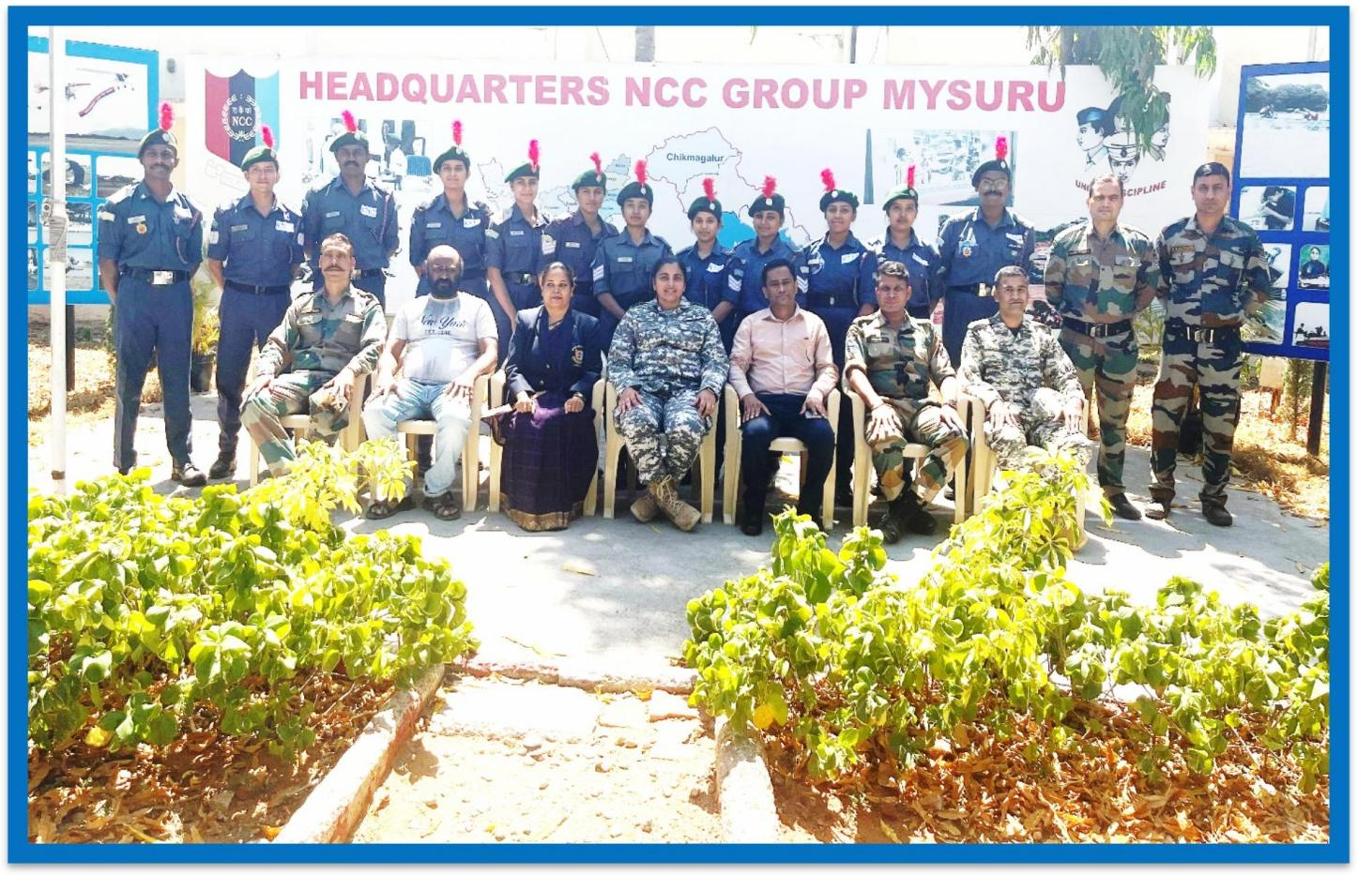

- Flt Lt Dr. N Vani Shree was detailed for evaluation of NCC C Certificate answer scripts from 4th March, 2024 to 10th March, 2024, at the 14 Karnataka Battalion, NCC Army Unit at the NCC Group Headquarters, Mysuru.

MUN ACTIVITIES:
- JSS Law College in collaboration with the Institute of Legal Research held an International Model United Nations with participants from Brazil, Afghanistan, Kenya, US, etc. The agenda was International Trade for World Peace. Our student Mohammad Subhan of 4th Sem BBALL.B won the Best Delegate, he was representing the country of Afghanistan. Smt. Asmathunnisa G co-ordinated the programme.

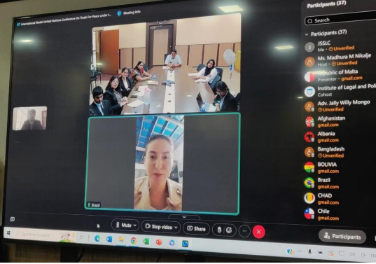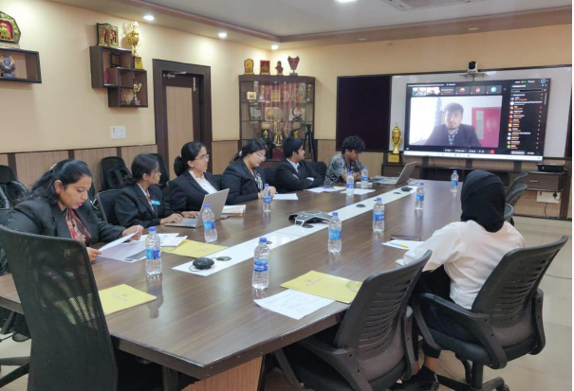

- The 10th edition MOP Vaishnav MUN was organized by the MOP Vaishnav College for women, Chennai.
The following students have secured laurels in:
1. Mohammad Subhan (4th Semester BBALL.B) – Honourable Mention
2. RK Pooja (6th Semester BALL.B) – Verbal Mention
