Monthly Report for the month of September 2023
The Activities Conducted for the month of September are as follows:
108th Jayanthi Celebration:
108th Jayanthi Celebration of His Holiness Jagadguru Dr. Sri Shivarathri Rajendra Maha Swamiji, Teachers Day, Inauguration of NSS, Sports and Other Co-Curricular Activities was celebrated in the college on 16-09-2023 and was inaugurated by Prof. K.S. Lokesh former Register, JSS Science and Technology University Mysuru. Chief Guest of the Program was Prof. M.B. Mallikarjuna Pandit former principal, JSS College of Arts Science and Commerce Mysuru. Program was presided by Prof. K.S. Suresh. Dr. S Nataraju Principal, Teaching and Non-Teaching staff and Students were present. The Program was coordinated by Sri. Suresh Kumar and Smt.Tejaswini M.
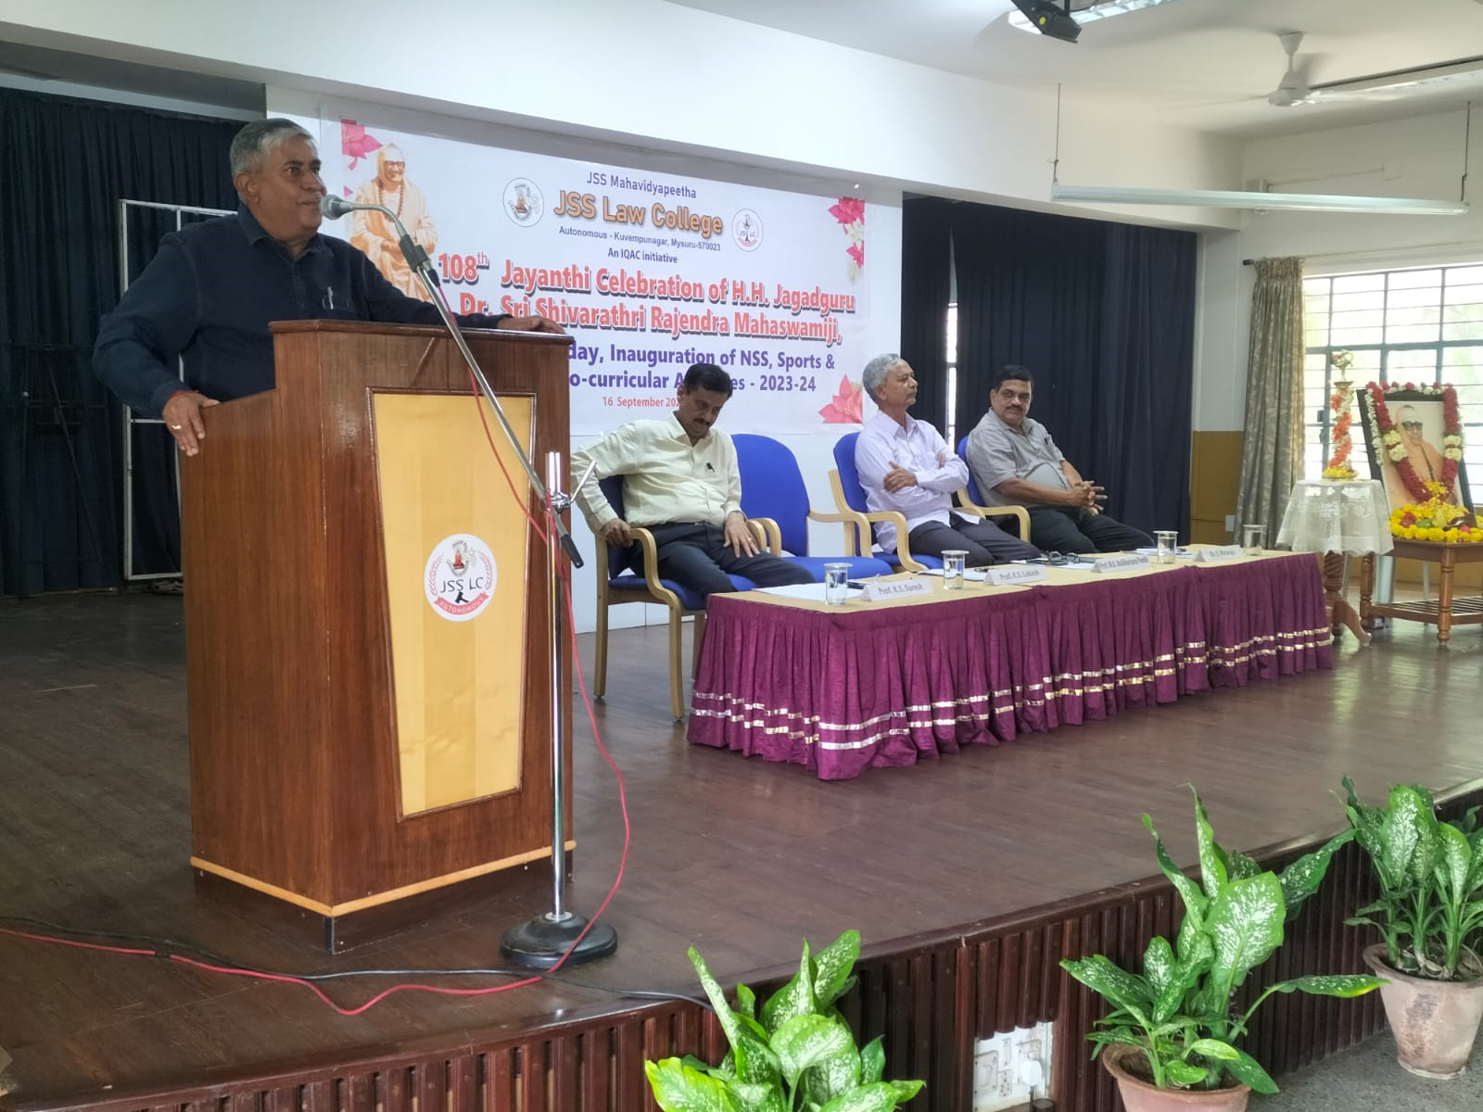

TRAINING SESSION:
JSS MUN SOCIETY conducted its first training session, for the first-year students at 3:20PM 06/09/2023, to inform them about the functioning of the MODEL UNITED NATIONS AND ALL INDIA POLITICAL PARTY MEET and procedures that need to be followed. There was around 110 number of students including various classes. The President (Mohammed Subhan, 2nd BBA LLB) of the JSSMUN society took the initiative to start the training sessions and elucidated over the committees of the UN and the ROP that should be followed.
The Vice-President (Bi Bi Nida Fathima, (2nd BA LLB) and the Director (Aamir Farzan Shariff, 2nd BA LLB) of the JSS-MUN society gave a very comprehensive and experience aided inputs and comments about Lok Sabha.

‘ART OF MOOTING’ Moot Orientation session
The moot orientation session was conducted in the Silver Jubilee Hall on 14.09.2023. The session started with welcoming the Guests and the speakers of the program were Ms. Smriti. K and Ms. Shama. D who are alumnus of this college. Ms. Nikitha one of the moot coordinators was the host of the session. Ms. Shivani. P. Murthy, the student moot coordinator welcomed everyone and Dr. N. Vanishree was present. All the First year and Final year students participated in the program.

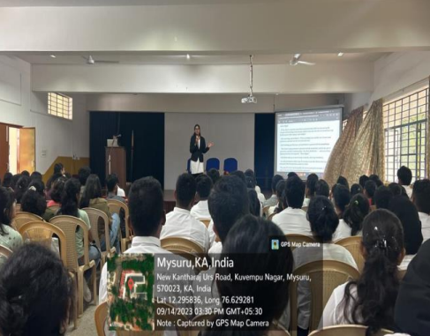

JSS-LC MUN SOCIETY REPORT ON “MOCK MUN, 2023”
JSS-LC MUN SOCIETY conducted its first event of the academic year 2023-2024 on 30-9-2023. It is a simulation of the actual Model United Nations Conference. The event consisted of two international committees and one Indian committee. The delegates for this Mock MUN conference were participants who will be participating in the Model United Conference held at the PES University, Bangalore on 7th, 8th and 9th of October. Ms Asmathunnisa Faculty, co-ordinated the programme.

Other Activities:
- Orientation Programme was organized for I Semester LL.B. students from 04.09.2023 to 21.09.2023.
- The Mentors'-Mentees Cell meeting was convened on 27.9.2023.
- Arambha-2023 Freshers Day was organized in the College on 23rd September 2023. The program was organized by 4th year BA/ BBA LLB students along with the students of 2nd year L.L.B. Cultural programme was held after the formal programme.

Teacher’s Achievements/Participation:
1. Smt. Sheela Ganesh published research paper titled "Legal Framework of Product Liability in E-Pharmacy" in the Indian Journal of Law and Legal Research (IJLLR), Volume V, Issue IV, pg. 1 to 16 (ISSN: 2582-8878) on 1.9.2023 available at Indian Journal of Law and Legal Research | IJLLR
2. Smt. Sheela Ganesh participated in the 7 Day Faculty Development Programme (Virtual) on "Intellectual Property Rights & Competition Law" organised by IQAC, Vivekananda Law College, Bengaluru from 5.9.2023 to 12.9.2023.
3.Soujanya G K participated in the 7 Day Faculty Development Programme (Virtual) on "Intellectual Property Rights & Competition Law" organised by IQAC, Vivekananda Law College, Bengaluru from 5.9.2023 to 12.9.2023.
4. Jagadish A T participated in certificate course on Legal Aspects of Artificial Intelligence organized by the School of Law, held on September 22-23, 2023 at AURO University, Surat, Gujarat.
5. Dr. Priya A Jagadish &amp; Jagadish A T participated in One Month National Level Online Refresher
Course on Teaching Law in 21st Century-Edition1 (40 Hrs) organized by Law Teachers India and Gujarat Maritime University, Gandhinagar from July 3 to August 5, 2023.
6.Tejaswini M attended 2 days Research Development Program on Fundamentals of Research on 11thand 12th September 2023 at SDMIMD College Mysuru.

Student’s Achievements/Participation:
- Cadet Warrant Officer Jiss Anthony of Vth semester BALLBwon the silver medal for Aeromelling at the All India Vayu Sainik camp 2023 held at Bengaluru
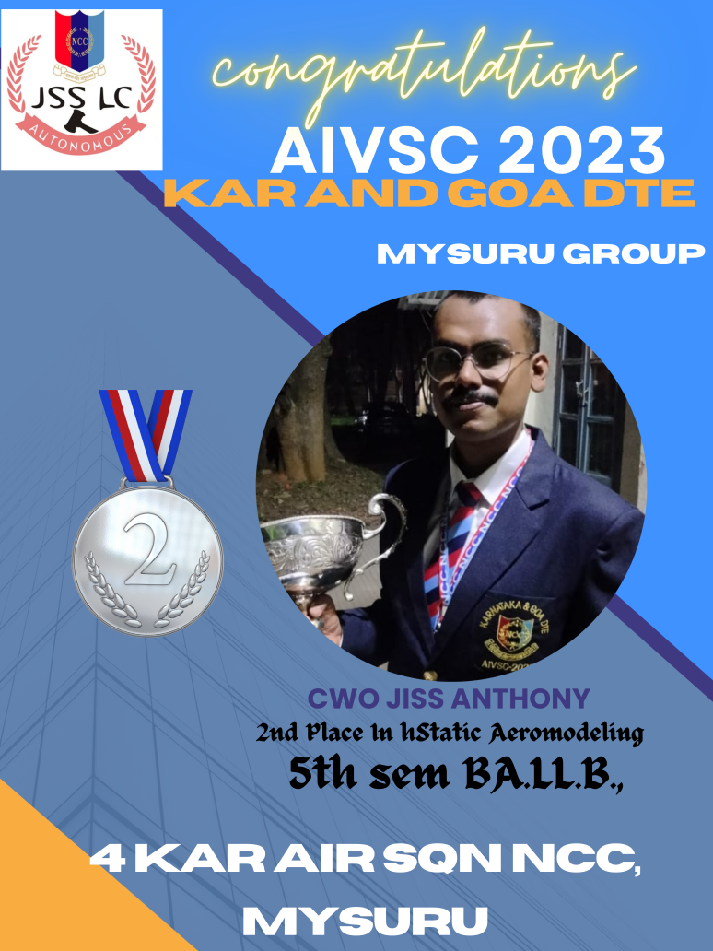
NCC ACIVITIES:
- The Pre Vayu Sainik Camp II was held at Belagavi from 31st August, 2023 to 9th September, 2023 organized by the 8 KAR AIR SQN NCC, Belagavi. The cadets from our college who participated are: Cdt Cpl Abhijith Koundinya G R from V Semester BBA.LL.B (Hons), CWO Jiss Anthony from V Semester BA.LL.B (Hons), CSgt Gowtham M from VII Semester BA.LL.B (Hons). 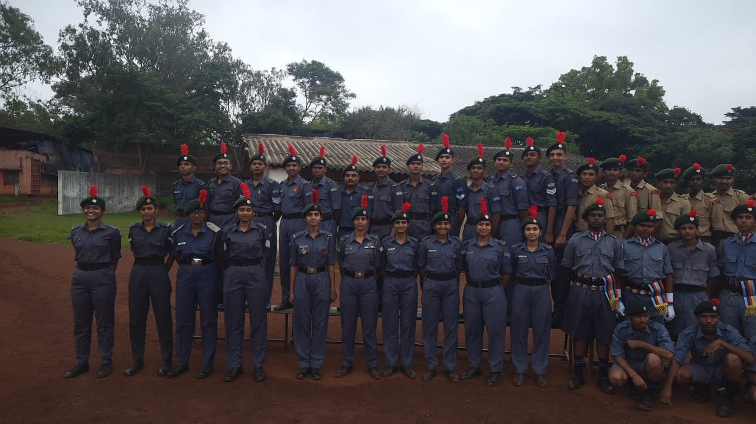

- The Pre Vayu Sainik Camp III was held at Bengaluru from 13th September, 2023 to 22nd September, 2023. Our college cadets who are participating in the camp are: CWO Jiss Anthony from V Semester BA.LL.B (Hons.), Cdt Sgt Gowtham M from VII Semester BA.LL.B (Hons.) and Cdt Cpl Abhijith Koundinya G R from V Semester BBA.LL.B (Hons).
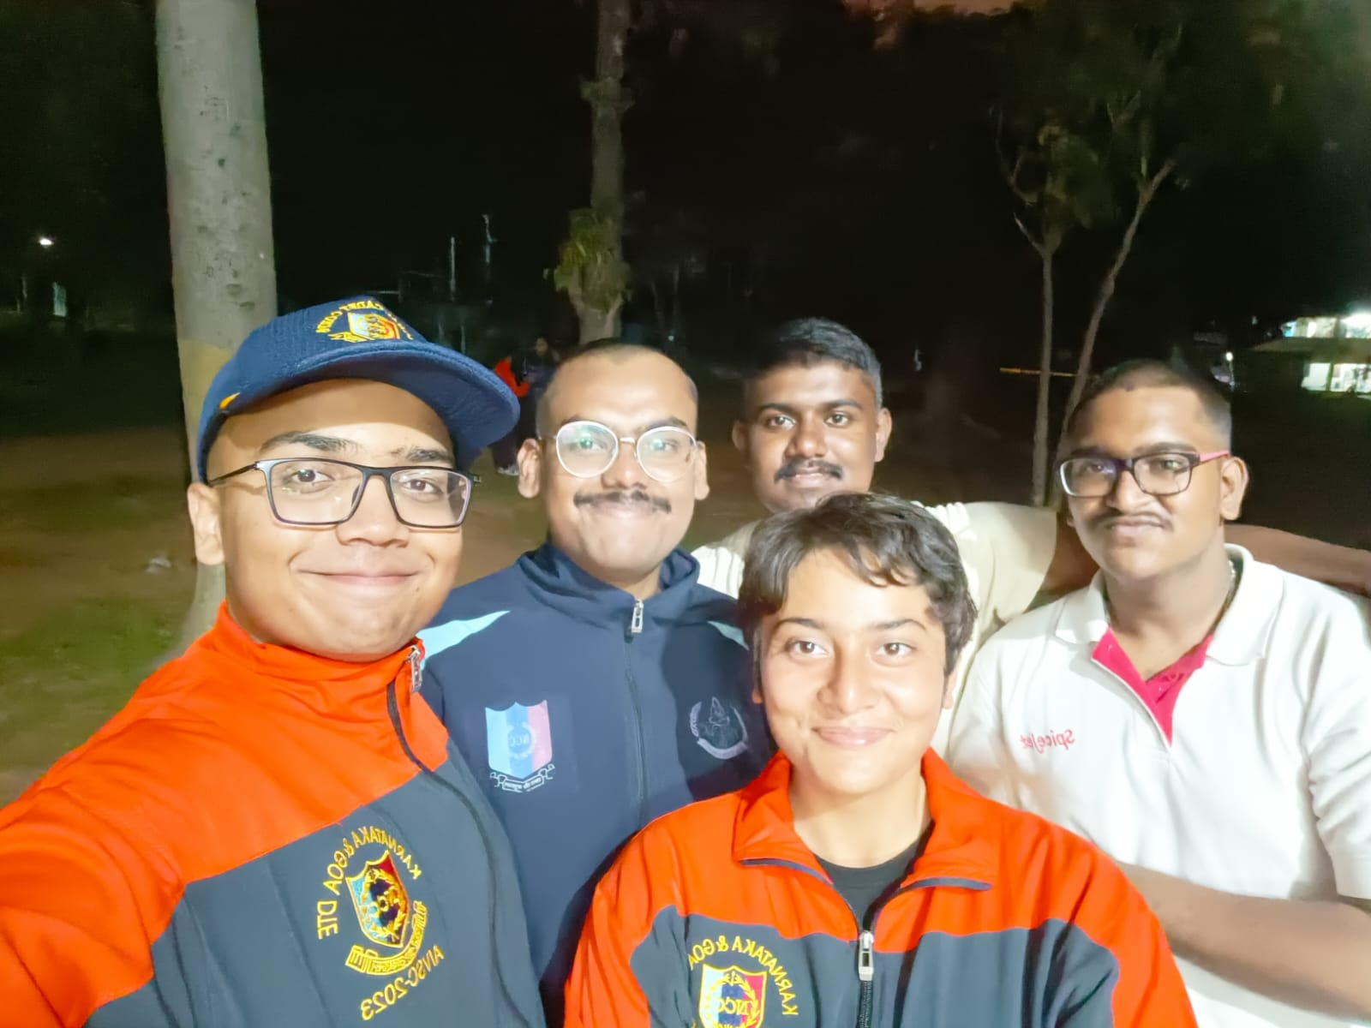
3. The All India Vayu Sainik Camp, 2023 was held at Bengaluru from 23rd September, 2023 to 4th October, 2023. Our college cadet who got selected for this National Level Camp is: CWO Jiss Anthony from V Semester BA.LL.B (Hons).
4. Flt Lt (Dr.) N Vani Shree was detailed and organized with around 26 cadets of JSS Law College Puneet Sagar Abhiyan (World Rivers Day) on 24th September, 2023, at Lingambudhi Nagara Udhyanavana, Lingambudhi Lake, Ramakrishna Nagar, Mysuru, Karnataka. The theme of the day was ‘’Say yes to healthy life and No to Plastic’’, and the students actively participated in the cleaning drive by creating awareness among the general public regarding the protection of the environment.
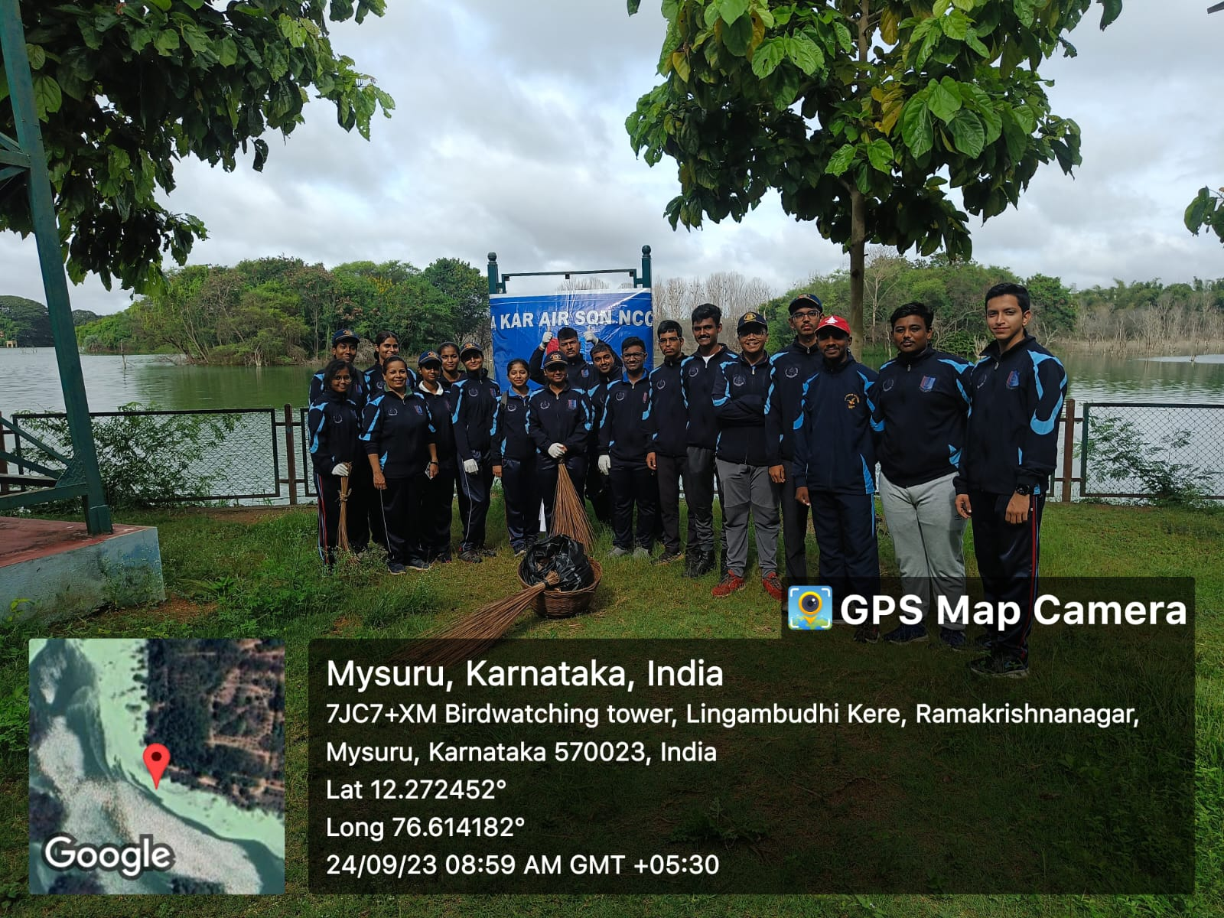
5. Flt Lt (Dr.) N Vani Shree was detailed and in charge of screening candidates for joining Air Wing NCC for the training year 2023-24 under 4 KAR AIR SQN NCC, Mysuru on 23rd and 24th of September, 2023, at SBRR Mahajana FG College Ground, Mysuru. Physical efficiency of the students was tested through Physical Efficiency Test which included running, push-ups and sit-ups. A written test on the topics of General Knowledge, Nation and the Armed Forces (the Indian Air Force in particular) was also held. There were around 160 students from different colleges including engineering, polytechnic, law and other streams of degrees from the Mysuru city who took part in this Enrolment drive.

