Monthly Report for the month of October 2023
The Activities Conducted for the month of October are as follows:
GOVERNANCE TALK SERIES:
‘THE 74TH AMENDMENT OF THE INDIAN CONSTITUTION AND ITS IMPACT ON URBAN GOVENANCE’

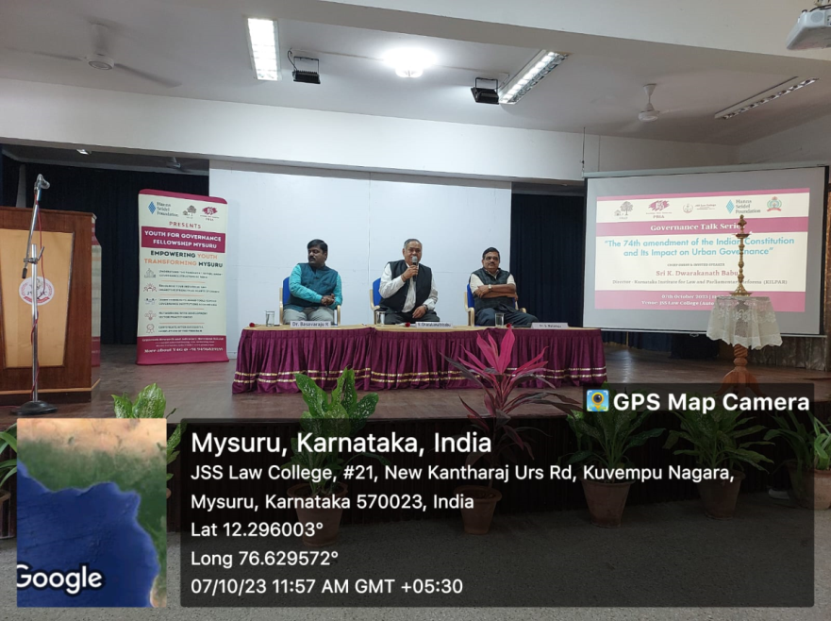
JSS Law College, Mysuru, in association with GRAAM Mysore organized special talk on the topic ‘THE 74TH AMENDMENT OF THE INDIAN CONSTITUTION AND ITS IMPACT ON URBAN GOVENANCE’, on 7th October 2023 at JSS Law College, Mysore. The chief guest and the speaker of the program was Sri. Diwakar Babu, Director, KILPAR, Bangalore who has delivered lecture on the 74th constitutional amendment. Dr. Basavaraju R Shreshta, Executive Director GRAAM highlighted the importance of the decentralization of powers and the democratic principles. Dr. S. Nataraju, Principal presided over the function. The students of JSSLC and research students from GRAAM and the staff of the college were present on the occasion.
Moot Court Society Activities:
On 5th October 2023, the Lecture on Art of Drafting in Civil and Criminal cases was conducted by the Moot Court Society, where the special lecture focused on various civil and criminal applications with reference to the use of Artificial intelligence.
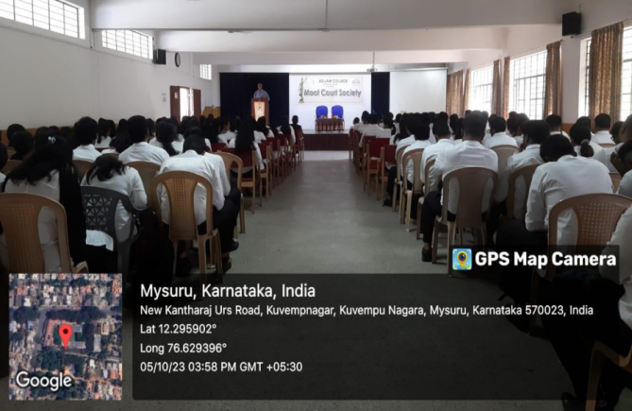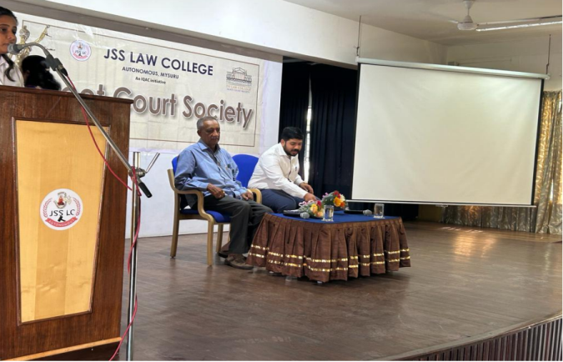

On 16th October, 2023 the Induction Ceremony of Moot Court Society 2023-24 was held, and the Intra Collegiate Moot Proposition was released followed by the badging ceremony for the members of the Moot Court Society.

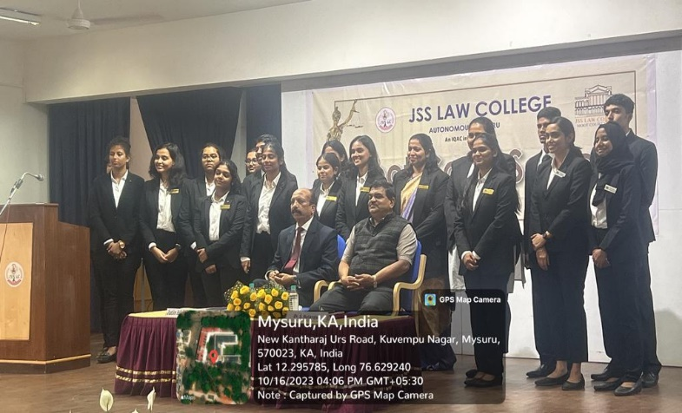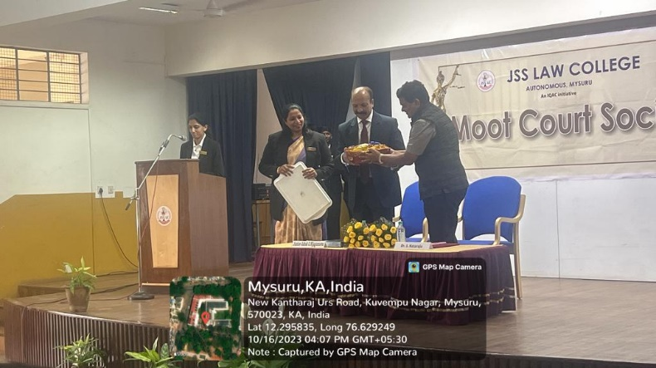

On 20th October 2023 the Basics of Mooting, Training Session – II was conducted by the Moot Court Society with special emphasis on the preparation for the Moot Court competition for the freshers.

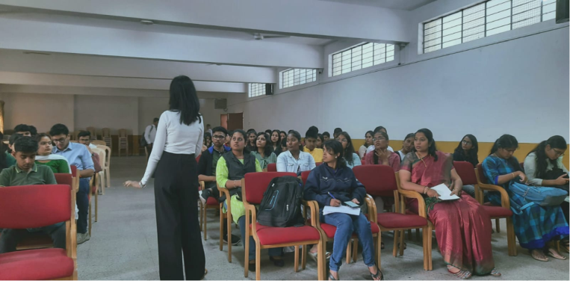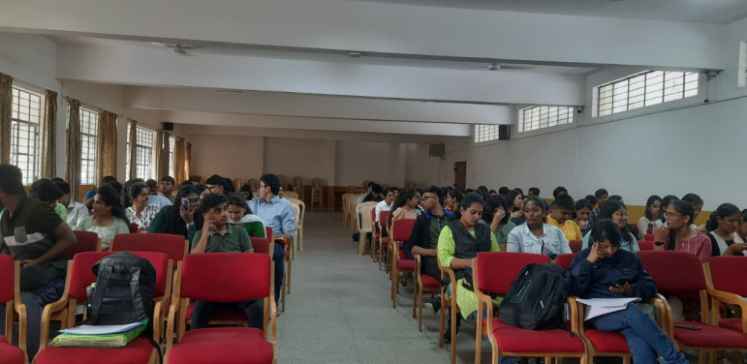

MUN Society Activities:
- On 6th October 2023 an induction ceremony was organised to officially appoint all the SOBs of the society. Stephen Anurag Prathipati presided as the Chief Guest of the ceremony and gave his valuable insights and boosted the morale of the society. Subsequently the poster of the IC-MUN and MVS-23 was released.
- On October 7th, 8th and 9th 32 Delegates were sent to the People’s Conference, PeCon, 2023 held at PES University, Bangalore.
- On October 17th, 18th, and 19th 32 Delegates were sent to the DOC Model United Nations Conference Organised by the Christ Deemed University Bangalore.
- On October 26th 2023 first official meeting was conducted to decide over the matters such as budget and expenses of the IC-MUN with inclusion of deciding upon the dates and time of the event.
- On October 30th 2023 MUN Society conducted its first official Model United Nations Conference in the academic year 2023- 24 that is the Intra Collegiate Model United Nations Conference, having two international committees and one national committee.
Other Activities:
- The birth anniversaries of the Father of the Nation Mahatma Gandhiji and Lal Bahadur Shastri were celebrated in the college on 2nd October, 2023.
- Short Term Course on Contract Drafting was organized for Batch A, 41 students of our college including UG & PG from 3rd October, 2023, to 11th October 2023. The class timings was from 4.00pm to 6.00pm with a break spread over 8 days (16 hours) bringing in the different skills like current trends in contracts, research, foresight and understanding the contractual business, structure and importance of contractual clauses, non-disclosure agreement etc.
- The Great White Pelican was adopted by making payment of rupees 25,000/- for a period of One year from 6th October, 2023, to 5th October, 2024. The money was contributed by the students and staff of JSSLC for this great gesture. Dr. N Vani Shree assisted by student coordinators took initiative for animal adoption scheme by Sri Chamarajendra Zoological Gardens, Mysuru.
- Students' Mental Health Training Workshop was organized on 21/0/2023. Dr.Manoj K. Pandey, Associate Professor & HOD, Dept. of Clinical Psychology, JSS MC &H, JSS AHER, Mysuru addressed 180 students of first year BA/BBA.LL.B & LL.B. The programme was co-ordinate by Sri.Jagadish A.T.

Teacher’s Achievements/Participation:
- Ms. Usharani M C Presented and Published a Paper on ‘Application of Personal Laws relating Marriage, Divorce and Maintenance-Need of Uniform Civil Code in India’ in the Multidisciplinary National Seminar on “Impact of Innovation and Research to Exploring New Challenges of Global Issues” Organized by ICSRD, Bengaluru in Association with ORBIT Innovative Academy, Jodhpur, Rajasthan. held on 14 & 15 October 2023.
- Ashray Chakraborthy published an article titled "THE LEGAL PERSPECTIVE OF THE GIG ECONOMY- WITH SPECIAL REFERENCE TO INDIA." in VBCL LAW REVIEW September, 2023 issue. Bearing ISSN NO. 2456-0480.
- Jagadish A.T published an article titled 'Role of Uniform Domain Name Dispute Resolution Policy and .IN Domain Name Dispute Resolution Policy in settling Domain Name Disputes' for the publication in Legalopus of SDM Law College, Mangaluru.

Student’s Achievements/Participation:
The students of our college participated in Yuva Sambrama held at the open air theatre, Manasagangotri, Mysore on 9th October 2023. 25 students participated in the program. The theme of the dance was 'Dhaiva Aaradane'.
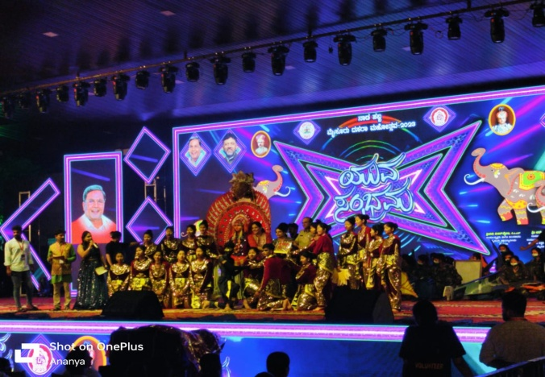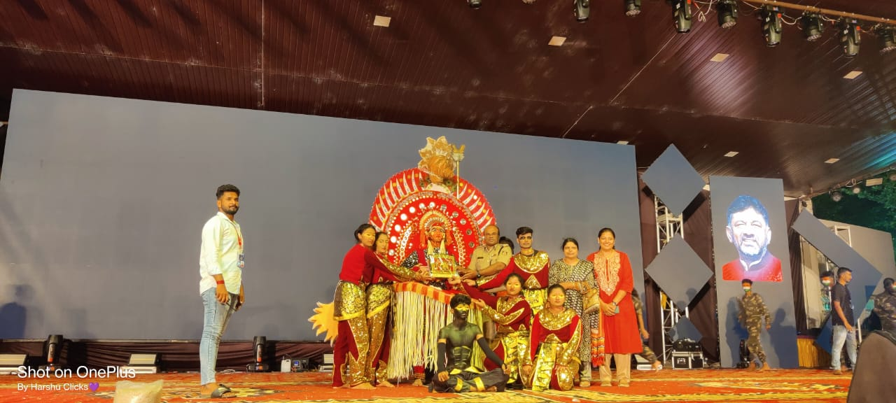

NCC ACIVITIES:
- Flt Lt (Dr.) N Vani Shree was detailed for CATC/GP Pre RDC-III at PTS, KSOU Campus, Mandakalli, MYSURU, with effect from 2nd October, 2023, to 10th October, 2023.
- Around 20 cadets, freshers from our college attended the interview for enrolment into NCC Air Wing at the Unit premises, on 5th October, 2023, out of which 15 of the cadets got selected for the Training Year 2023-24.
