Monthly Report for the month of December 2023
The Activities Conducted for the month of December are as follows:

Moot Court Society:
- On 5-12- 2023, the Moot Court Society had organized Judgment Writing(virtual) competition for the registered participants of the Intra-Collegiate Moot Court Competition 2023-2024.
- On 8 -12- 2023, the Moot Court Society conducted a Training Session for the registered participants of the Intra-Collegiate Moot Court Competition 2023-2024 focusing on the proposition, identifying related cases, and areas of improvement including feedback session.
Mun Society Activities:
- JSSLC MUN Society had sent a delegation to the MACE Model United Nations Conference, 2023 organised by The Mar Athanasius College of Engineering, Kothamanalam from 1-12-2023 to 3-12-2023. Abhijeet Koundinya. G. R, 3rd Sem. BBA. LLB; and Aadharsh Shakthi, 5th Sem BA. LLB; were awarded with Special Mention and Guhan Babu, 5th Sem BBALLB; was awarded with Hon’ble Mention.
- JSSLC MUN Society had sent a delegation to the KLECB Model United Conference, 2023 organised by the KLE Law University, Belgavi from 7-12- 2023 to 9-12-2023. Bibi Nida Fathima, 3rd Sem BA. LLB; was awarded Special Mention and Gaana V S, 1st Sem BA. LLB; Vaishnav Kiran, 1st Sem BA. LLB; Sudhiksha Jalihal, 1st Sem BA. LLB; Shreyas Aadhithya, 1st Sem BA. LLB; Vivek. M, 1st Sem, BBA. LLB were awarded Verbal Mention.

College Activities:
- On 18.12.2023 the Students’ Academic Council meeting was convened at Moot Court Hall at 3.30pm.
- On 19.12.2023 an Exhibition on Legal Methods and Research was organised by I Semeste B.A. LL.B and B.B.A LL.B, Coordinated by Smt. Sheela Ganesh, Course Teacher. Dr. Sridevi Krishna, Assistant Professor, Vidhyavardhaka Law College, Mysuru and Dr. S. Nataraju inaugurated the exhibition, following which Dr. Sridevi Krishna delivered a Talk on Legal Methods and Research addressing the I Semester B.A., LL.B and B.B.A., LL.B students (118students participated in the exhibition).
- Drama De la Corte series 4 (courtroom drama) was held in the college on 14-12-2023. All the BALLB Students took part in the drama. 32 girls and 28 boys were a part of the program. The event was coordinated by Smt. Nandini.
- III Sem B.B.A.LLB students visited Infosys Ltd. on 13-12- 2023 as a part of Human Resource Management Practical Component. It was organized by the Course teacher Tejaswini M.
- The IIQA (Institutional Information for Quality Assessment) for the final submission of SSR (Self Study Report) and the peer team visit was submitted to the NAAC on 5-12- 2023, by the college team for evaluation.
- The PG Faculty meeting was held on 6-12-2023, to discuss about the activities and examination related aspects including internal assessment components and dissertation.
- Dr. S Nataraju, Dr. N Vani Shree, Ms. Usharani M C and Mr. Madhu Kumar N attended an online meeting scheduled along with the Joint Director’s office for NAAC Accreditation Aided colleges on Wednesday, 6 -12- 2023, at 11.00am. The meeting was addressed by the Joint Director and SQAC-DCE Nodal officer K Vikram and an interactive discussion on colleges in Mysuru, which require NAAC Accreditation and AISHE documents.
- The 3 member KSLU Review Committee for Autonomous Status had visited the college on 30-12-2023.

Teacher’s Achievements/Participation:
- Mrs. Asmathunnisa G delivered a special talk on Power of Attorney, Wills and Inheritance at the Home Management Session conducted by MMK and SDM MahilaMaha Vidyalaya on 9 -12-2023.
- Mrs. Asmathunnisa G attended a Pan- India workshop on ‘India – Australia Partnership Framework on AI, Quantum and Critical Technologies enabling Digital Economy’, organised by Gujarat National Law University, India and Victoria University, Australia which was held on 14-12- 2023.
- Smt. Sheela Ganesh attended the 7 Days - National Online Faculty Development Program (FDP) on Human Rights organised by Department of Law, Central University of Karnataka from 11.12.2023 to 17.12.2023.
- Smt. Sheela Ganesh published an article titled ‘Pill or Kill – an insight into the Pharmaceutical Trademark Infringements’ in an edited book titled ‘Changing Scenario of Intellectual Property Rights and the Way Forward,’ published by Vaikunta Baliga College of Law, Udupi bearing ISBN: 978-93-91155-97-1 at pg. 197 – 208.
- Dr. N Vani Shree provided a Letter of Recommendation to Ms Koushalya to pursue her Masters’ Programme on Intellectual Property and Information Technology Law at Trinity College, Dublin, Ireland and University College, Dublin, Ireland on 13-12- 2023.
- Dr. S Nataraju, Dr. N Vani Shree and Mr. Chidananda attended the Two-Day Institute for Academic Excellence’s 5th National Level Workshop on NIRF India Rankings 2024, for Higher Educational Institutions held on 13th & 14th December, 2023 through Online, conducted by The Institute for Academic Excellence (IAE), Hyderabad.
- Dr. N Vani Shree provided a Letter of Recommendation to Ms Sherin Susan to pursue her Masters’ Programme on Intellectual Property Rights at Georgia State University, USA, on 22 -12- 2023.
- Dr. N Vani Shree provided a Letter of Recommendation to Ms. Hrishika Suresh on 9-12-2023, to pursue her Masters’ Programme at Kings University, UK.
- Dr. N Vani Shree, Course teacher of Law of Environment and all final year students of B.A.LL.B., BBA.LL.B and LL.B. organized an Awareness Programme on ‘Better Environment Better Tomorrow’ on 9-12-2023 at 10.30am in the college premises. Around 110 students gave presentations to the junior classes educating them about the various sub-themes like Climate change, Sustainable Development and Environmental problems & Solutions bringing about awareness and responsibility among the student fraternity.
- The Chief Executive Prof. K S Suresh, the Principal Dr. S Nataraju, Dr. N Vani Shree and other faculty members and around 100 students of our College attended the online Consultation Programme on ‘’Vikasit Bharat@2047: Voice of Youth’’ Ideas Portal launching by our Honourable Prime Minister Modiji and his special address via Video Conference on 11 -12- 2023, from 10.30am onwards via live Webcast arrangements made by our institution. Our college was also an active institution to involve in promoting the campaign.
- Jagadish A T completed the 4th Edition of Short -Term Course on Legal Aid and Allied Laws organized by Pro Bono India in collaboration with Centre for Legal Aid Programme, National University of Study and Research in Law, Ranchi supported by Department of Justice Ministry of Law between November 6th and December 2nd 2023.
- Jagadish A T published article titled ‘Role of Uniform Domain Name Dispute Resolution Policy and IN Domain Name Dispute Resolution Policy in settling Domain Name Disputes’ in Legal Opus Issue No. 155, 2023 of SDM Law College Managaluru. ISBN:978-93-5570-939-4.
- Jagadish A.T & Dr. Priya A Jagadish published article titled ‘Protection of Intellectual Property Rights in Cyberspace’ in Vaikunta Baliga College of Law Journal ISBN:978-93-9155-97-1 December 2023.

SPORTS ACTIVITIES
- Our College Basket ball & Throw Ball (women) Teams participated in HH Jagadguru Dr.Sri.Shivarathri Rajendra Mahaswamiji Memorial Basket ball & Throw Ball (women) Tournament, hosted by JSS Science and Technology University, Mysore held on 8 -12-2023 at SJCE Sports Ground.
- The College had organised Annual Inter Class Football Tournament at Kannegowda Sports ground, K.G.Koppala, Mysore on 5th & 6th December 2023.
- Our College Volley ball, Throw ball and Athletics teams participated in JSS Inter Institution Sports Tournament held from 16th to 19th December 2023 at Suttur Srikshetra. Our Women relay team secured third prize in 4x100mtrs relay.
- Our College Chess Team participated in HH Jagadguru Dr.Sri.Shivarathri Rajendra Mahaswamiji 108th Jayanthi memorial School & College Chess Tournament, hosted by our College held on 23.12.2023 in the Silver Jubilee Hall. Our College Students Ms.Janani.R secured First Place and Mr. Amogh secured second place.

NCC ACIVITIES:
- The Second-year cadets of JSSLC Air Wing Cdt Cpl Nanda Hattikal, Cdt Bhoomika Jain S N and Cadet Chandana V S were guided on the Simulator and taught the basics of flying and the parts of an Airplane on 6-12- 2023, at 3 Girls Battalion NCC, Mysuru Group at 2.30pm.
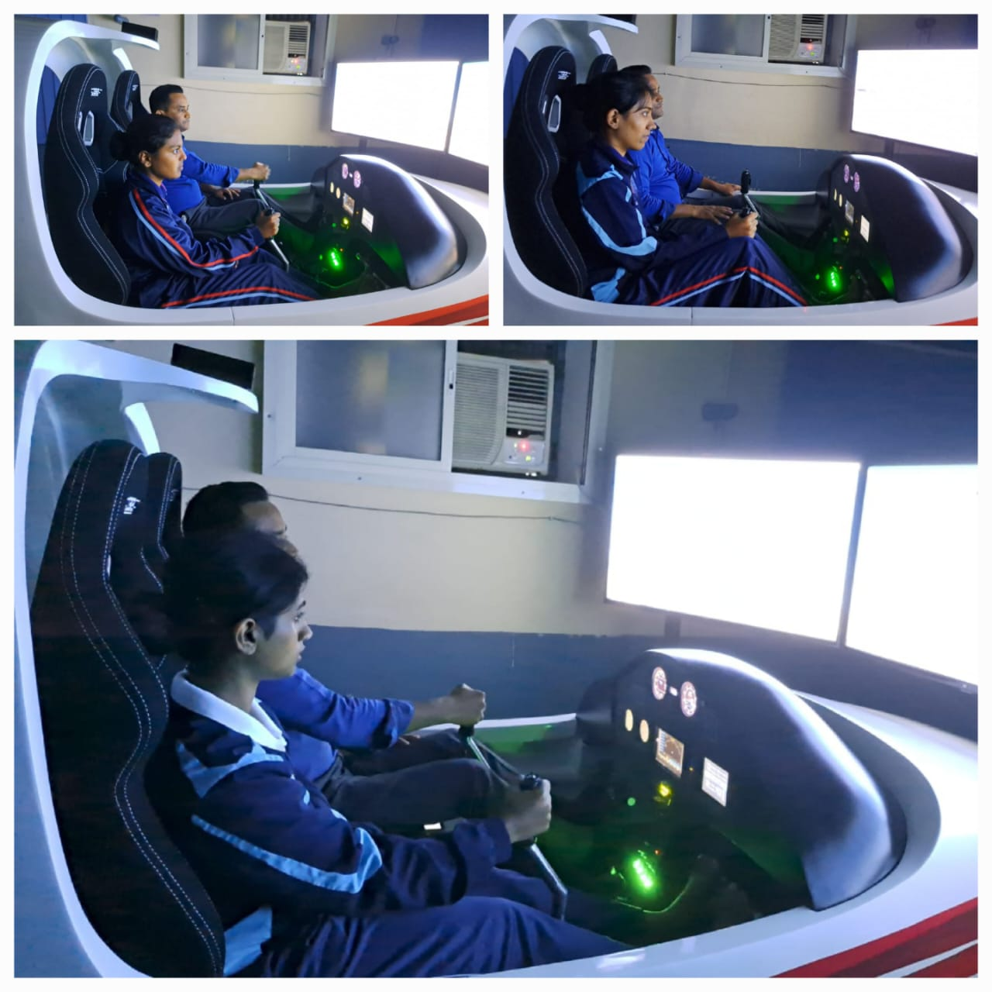
- The NCC cadets of our college participated in Poem Writing and Essay Competition on the topics Pollution Control and Benefits of Millets organized by the 4 Kar Air Sqn NCC Unit on 9-12- 2023, between 2.00pm to 4.00pm.

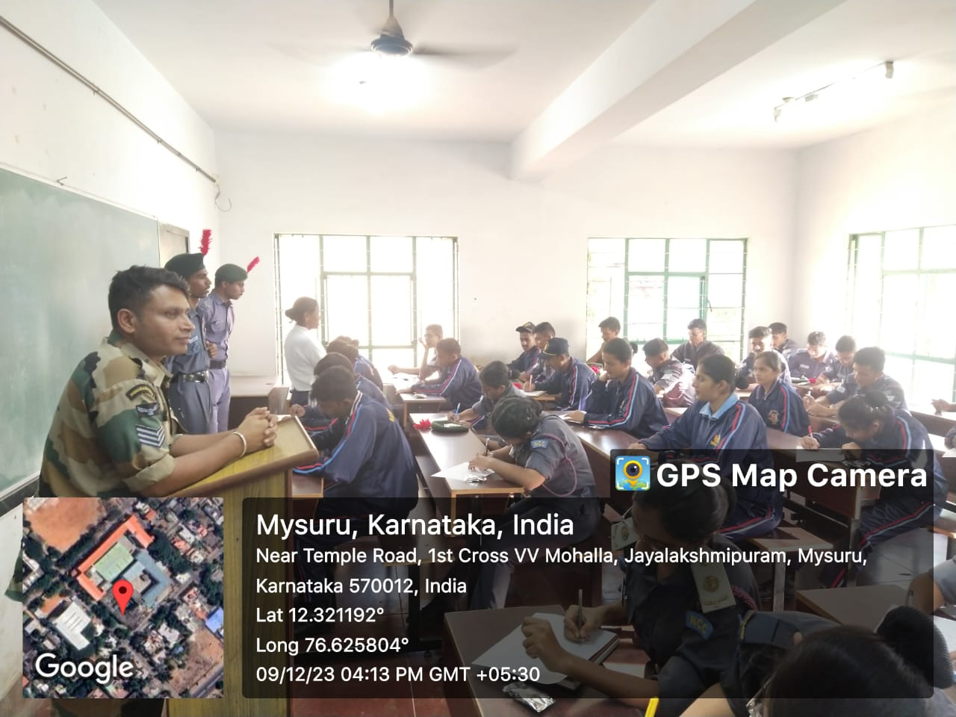

- Our prize-winning Static Aero-model (BAE Advanced Hawk MK – 132) made by CSUO Jiss Anthony and team who were the prize winners and silver medallist at the AIVSC 2023 at Bengaluru, was sent to New Delhi for display during the Republic Day Parade, 2024, on 21-12- 2023.

