Monthly Report for the month of August 2023
The Activities Conducted for the month of August are as follows:

A REPORT ON DEEKSHARAMBH: ORIENTATION- 23
The year’s auspicious session, Deeksharambh Orientation Program for the freshers’ was held from 3rd to 14th August 2023 in the college Silver Jubilee hall.
DAY - 1 (03-08-23)
The orientation programme began with an invocation by Miss Jhanvi. Dr. S. Nataraju, Principal, welcomed the gathering and Dr. N. Vani Shree introduced the Chief Guest. Later, the programme was formally inaugurated by Gp. Capt. Abhinav Chaturvedi, Commanding Officer, 4 Kar Air Sqn NCC, Mysuru Group, Mysuru along with Prof. KS Suresh, Chief Executive and Dr. S Nataraju by lighting the lamp.
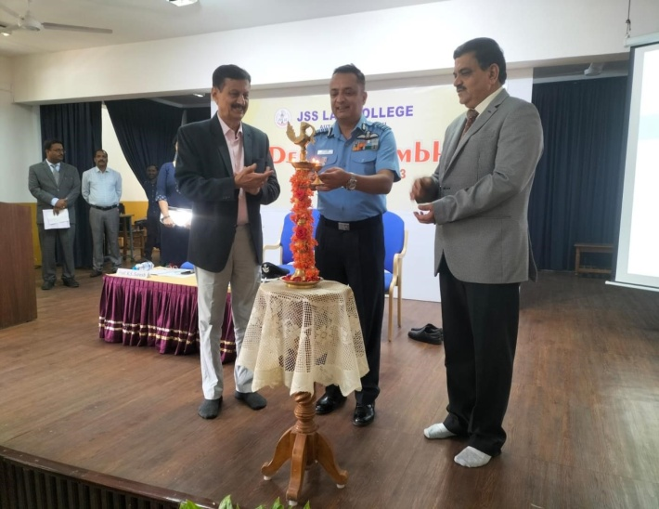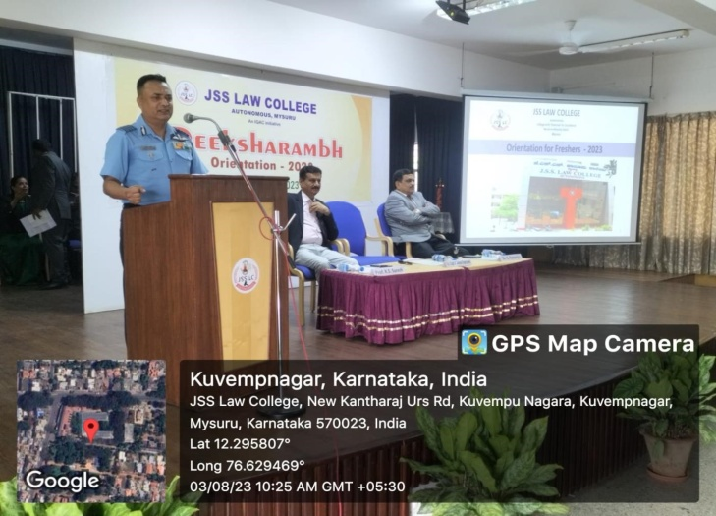
In the inaugural address, Capt. Abhinav Chaturvedi narrated his experiences in the initial days at the training, and further added his experience at the Kargil. He addressed the parents, on their role in shaping the career of their wards.
The programme concluded with the vote of thanks by Smt. Sheela Ganesh. The programme was compered by Sri. A. T. Jagadish.
After the formal function, Prof. KS Suresh gave an overview of JSS Mahavidyapeetha and JSS Law College. Then, separate sessions were conducted for the parents and the students in the later half of the day. The parents were informed about their roles and responsibilities along with clarifying their doubts. The students on the other hand were made comfortable through mutual conversation to adjust to the new environment.

DAY - 2 (04-08-23)
Day 2 of the DEEKSHARAMBH program began with the ice breaking session for the students in which, they were made comfortable by the faculty of the college. The students began with Self-introduction in which they were encouraged to express freely about their likes and dislikes, interests, and hobbies. Some students came up to display their talents.The ice-breaking session was conducted for BA LL.B students in the Silver Jubilee hall by: Sri. P Shivananda Bharati; Smt. Usharani; Smt. Sheela Ganesh; Smt. Nandini M.S; Smt.Asmathunnisa G and Sri. Ashray Chakraborty. For the BBA LL.B students, the session was conducted in the Moot Court hall by: Sri. M.P Nagendramurty; Sri. Jagadish A.T; Smt. Sunitha N; Smt. Tejaswini and Sri. Pranav Nair.
During the second session, Sri. H.S Renukaradhya, Deputy Superintendent of Police, Assistant Director, Basic courses, Karnataka Police Academy, Mysuru spoke on the topic “AWARENESS AND PREVENTION OF CYBERCRIMES” Sir spoke about the various methods of Cyber-crimes in the society and emphasised on the line between privacy and disclosure. He further explained the methods through which the students can avoid becoming victims of such crimes. He stressed on the punishments for the offences regarding cyber-crimes committed by a person knowingly or out of ignorance.
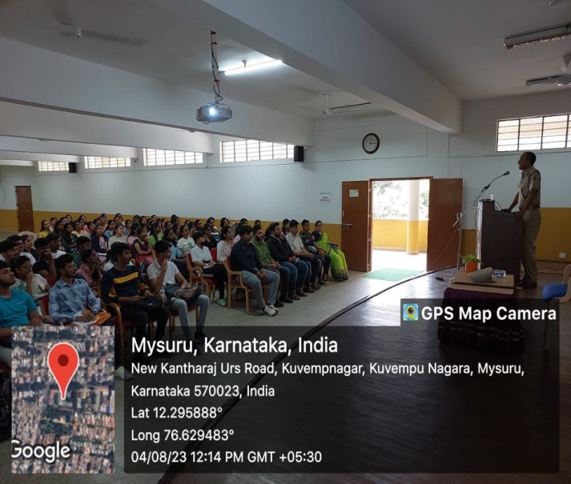
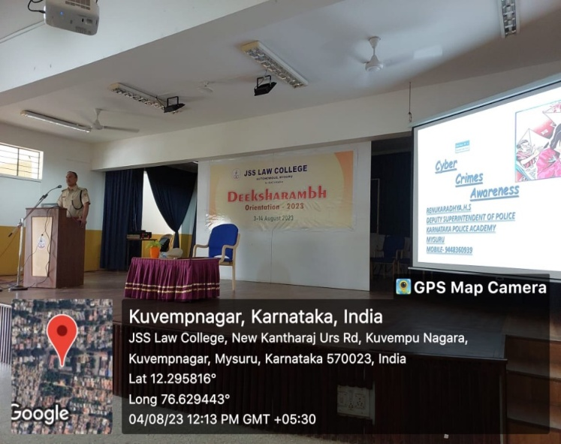
DAY - 3 (05-08-23)
The first session was the Alumni Interaction with Ms. Saloni Olivera, Ms. Shama D, Ms. Aria Philips and Mr. Satish. Ms. Saloni Olivera shared her experience at the National Law School of India University, Bangalore (NLSIU) and also her experiences at the NGOs. Later , Ms. Shama D, explained the importance of research in moot competitions. Mr. Satish V who is a Software Engineer, and a Law graduate shared some insights about the experiences he had in the college. At last, Ms. Aria Philips greatly emphasized on the skills needed for moot court competition. She explained the basic skills needed for effective speaking at the moot courts. All the alumni reiterated on the fact that that internships should be taken very seriously.
In the afternoon session, the students were addressed about General Subjects by Smt. Nandini M S where she highlighted about the importance of English and Kannada as legal languages. Later, Sri Jagadish A T introduced the Law subjects.

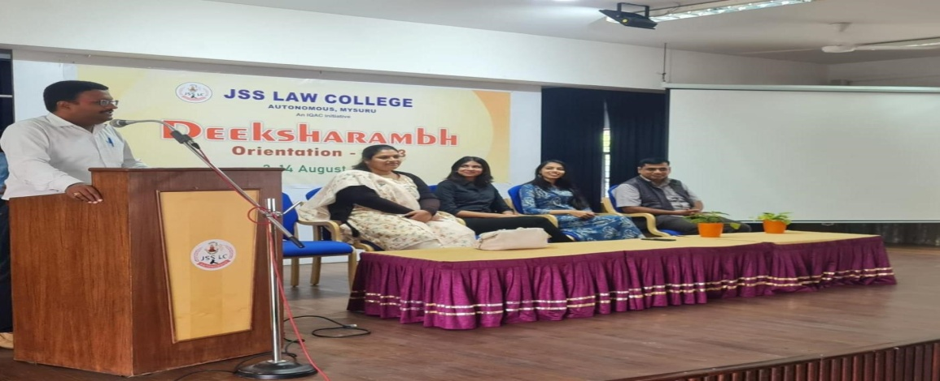
DAY – 4 (07-08-23)
In the morning session Prof. K.S. Suresh gave a talk on “Career Opportunities in Law.” He mainly focussed on the other avenues open to the Law students.
In the second session, Dr. Capt. Indrani MR, Department of English, SBRR Mahajana college, delivered a special lecture on the topic “Importance of Legal Language”. She gave the historical background of legal language, and highlighted the 5-dimensional approach to communication. She also spoke about various life skills that a lawyer needs. At last, she even shared some Tips for communication a student of law needs.

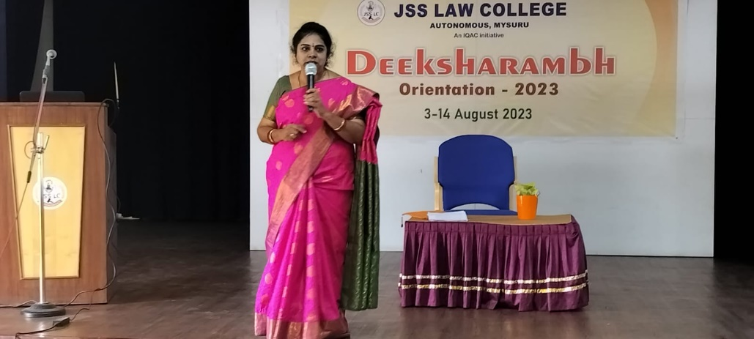
The third session was conducted by Sri. M Nagendramurthy, he reiterated the importance of law to the students and its uses in the society. He then explained about the Legal Aid Clinic. He also emphasised the importance of Rotaract club and Anti Ragging Cell.
DAY – 5 (08-08-23)
In the session 1 of the day 5 of orientation, Amith Parva, teacher at Rangayana, Mysuru gave a talk on the topic, “Introduction to Theatre.” He then explained the role of theatre in shaping the society. He briefed about the history of Rangayana, a prominent theatre in Mysuru, established by B.V. Karanth, director of National School of Drama, New Delhi in the 1980s. He even emphasised that theatre is a mirror to the society and that’s why drama becomes an important aspect in everyone’s life.
The second session was conducted by Smt. Asmathunnisa G. Madam formally introduced the Moot Court Society to the students. She explained the importance of moot court in the career building which involves public speaking. She then told that any student who has taken admission at JSS LAW COLLEGE automatically is a member of Moot Court Society.
During the third session of the orientation, Dr. S Nataraju, Principal; introduced the students to the Student Guide. He spoke about the maintenance of discipline and the decorum the college demands from everyone. He highlighted about some concepts from the student guide like the common aspects related to uniform, discipline, attendance, mobile phone etc…
In the session 4 of the orientation, Sri. Kumar from Karnataka Police Academy, Mysuru, conducted a session on Traffic Rules and its Importance. He also told the importance of Golden hour and introduced the concept of Good Samaritan. The session was proved to be highly educational and informative.

DAY – 6 (09-08-23)
In the first session, Dr. Manasa S D, Assistant Professor, JSS Ayurveda College explained the Problems in Adolescence. She mentioned the changes in our body such as, rapid physical growth, physiological development, cognitive development etc… Then, she explained the problems related and some methods to avoid them.

In the session 2, Dr.N. Vanishree formally introduced the main body of the college- IQAC (Internal Quality and AssuranceCell) to the students. She explained its function, and the role it plays in the college.
She also explained about importance of NAAC in assessing every higher educational institution and its impact on theinstitutions.
Later, she introduced NCC (NATIONAL CADET CORPS)
Our institution has Air wing of the NCC. She then talked about the activities NCC undertakes and displayed the pictures of some of the achievers who excelled from NCC.
In the last session of day 6 of the orientation, CS PAVITHRA conducted a talk on Neuro -linguistic programme.
She gave examples of many prominent lawyers such as Nani Phalkivala, Harish Salve and reiterated that it is the lawyer through whom the society will experience change and it is the lawyers who have the potential to bring the change.She explained the skills required for a lawyer. At last, she shared some tips and tricks to be a successful lawyer.
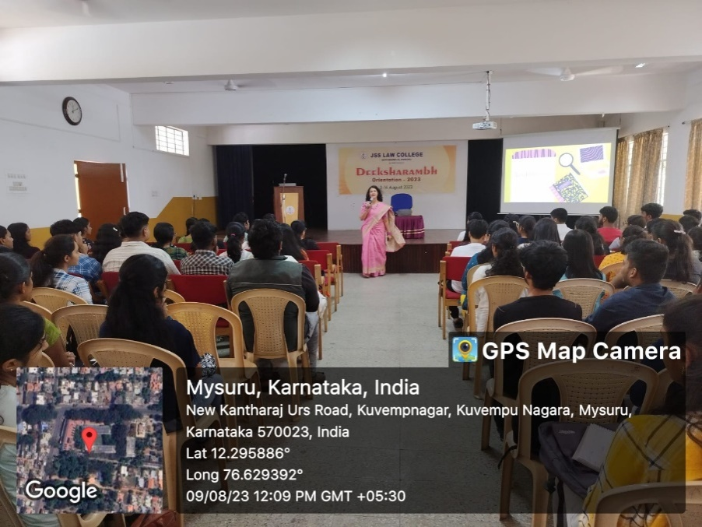
DAY – 7 (10-08-23)
In session one of the orientation, Smt. Sheela Ganesh introduced Mentor cell and Student academic council.
She also explained the functions of Student Academic Council.
In the session 2 of the day-7 Yogatma Srihari, Chairman, GSS Foundation, Mysuru, inspired the students by citing an example of ARUNIMA SINHA, who, even after facing numerous obstacles, climbed the Mt.Everest.
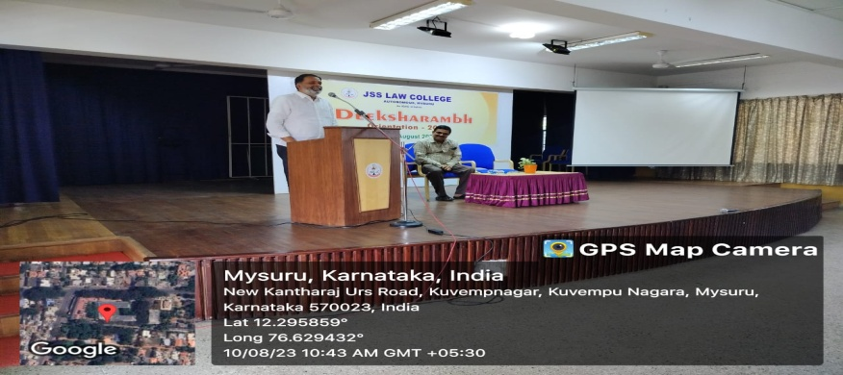

The last session of the day 7 of the orientation was conducted by Sri. Pranav Nair.He explained the students about NEETI forum, which involves in inviting senior and retired judges of Supreme Court and High Courts of India, to talk about practical aspects of law.
He also talked about the activities conducted by the forum in the past years.
DAY – 8 (11-08-23)
In the first session of day 8 of orientation, Smt. Sunitha N introduced the curriculum of BBA LL.B. Smt. Nandini MS introduced the common subjects for both BA and BBA students and also introduced the curriculum and subjects related to BA LL.B. Later, Sri. Jagdish A.T introduced the law subjects.
Inthe second session of the orientation, Smt. Nandini MS introduced the Parents committee , CIA Monitoring and redressal committee and Grievance cell. She also explained the way these committees function and also mentioned the importance of these committees.
In the third session of the orientation, Shri. Ashray Chakraborty, introduced the GREEN GUIDES club to the students whose sole objective is to sensitize the students on environment and ecology and to involve the students in eco-friendly practices. Sir also explained various laws safeguarding our eco-system.
In the session 4 of the orientation, Professor P Shivananda Bharathi, Controller of Examination explained the process of examination and evaluation adopted at JSS LAW COLLEGE. Sir explained the LTP method and the importance of Internal (CIA) and external examination marks which amounts to be 30 and 70 respectively for each subject. He then explained the promotion scheme and the requisites required for promotion to 5th, 7th and to 9th semesters respectively. At last, he shared some important tips to tackle the examination with ease and to score good marks.
In the last session of the orientation, the Librarian Sri.Chidananda formally introduced the library to the students.
He explained various methods for the students to access the old case files and the methods to do research using databases such as Manupatra available in the library.
DAY – 9 (12-08-23)
The session was conducted by Smt. Swati Sharma, Company Secretary. She stressed on the fact that “Skill is the most needed aspect than marks”
She encouraged the students to learn to adapt and embrace change as knowledge jobs are the future. She then explained various branches in law and stressed mainly on CORPORATE SECTOR and clearly explained what really a COMPANY SECRETARY is. She then pointed out the need for company secretaries in a country such as India as it is proving to be a hub of investments and a start-up hub. She even told that CS are the doctors of the corporate world. She also pointed out the various career opportunities after an individual becomes a CS and gets registered with ICSI.

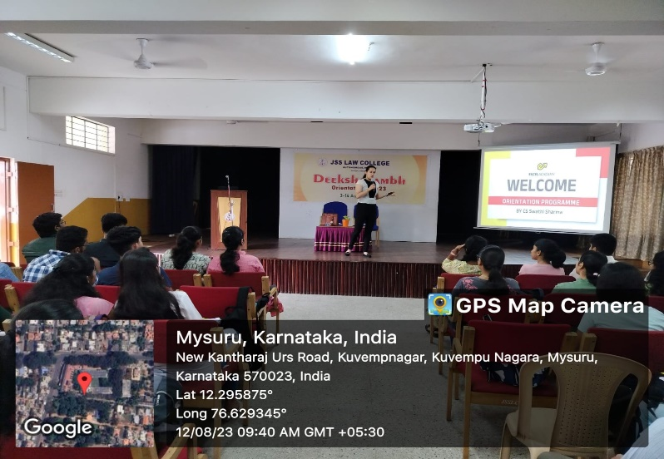
The session 2 of the orientation was conducted by Sri. Suresh Kumar, Director, Department of Sports, JSS LAW COLLEGE who formally introduced the sports department to the students. Sir instructed the students about the rules of using GYM, yoga and other facilities provided by the college. He also informed the procedure for forming college teams. He then highlighted the achievements of the students who took part in various sports tournament and the laurels brought to the college.
In session three, Dr. Priya A. Jagadish, introduced the statutory committees of the college to the students, which are SEXUAL HARRASMENT PREVENTION COMMITTEE, ICC and WOMEN’S CELL. Madam explained about the need of these statutory bodies and the procedures related to them.
In the last session of the orientation, a special session was conducted by Shri. Akarsh S, Civil Judge, First class Judicial Magistrate, Yelandur, Chamarajnagar district and a proud alumnus of this institution.
Sir delivered a talk on Judiciary as a career.
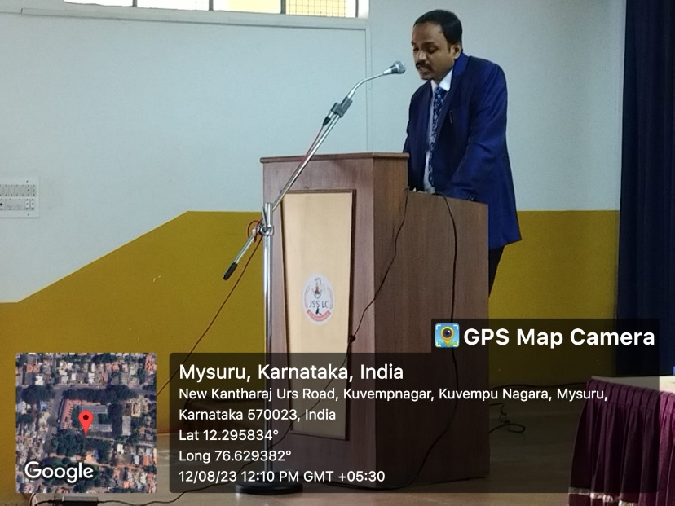
DAY – 10 (13-08-23)
In the session one of the orientation, Professor K.S Suresh, Chief executive of JSS LAW COLLEGE, conducted a session on “Legal System in India.” Sir emphasized on the matter that, if anyone learns anything with perfection, then he/she will become the most promising and the most successful individual in that field.
Sir then taught about different types of court our country has. Then, he distinguished between inquisitional and adversarial law. He then defined traditional and non-traditional methods of legal practice. Then, he taught the requirements a lawyer needs to excel in the legal profession. In the second session Smt. Asmathunnisa spoke about the Foreign National’s Cell and Minorities cell.
The third session was conducted by Smt Tejaswini madam, who is the co-ordinator of the Cultural Committee at JSS LAW COLLEGE. She told about the Drishti wall magazine and even explained the functioning of the Placement cell in the college. In the session 4 of the orientation, Dr. S Nataraju, the Principal of the college, introduced Law to the students. He first explained the general meaning of law and then emphasized on the need for Justice. He also introduced different law streams.
DAY – 11 (14-08-23)
On the last day of the orientation, the students were given a test in Online mode on English and Computer Application in order to assess the performance of the students during the 11 days of the orientation.
120 STUDENTS from BALLB and BBALLB attended the orientation Programme out of which 78 were girls and 42 were boys. The orientation session was jointly coordinated by Sri. Jagadish A.T and Smt. Nandini M S.
BRIDGE COURSE:
Bridge course for I Semester BA LLB and BBA LLB Students was conducted from 17th to 31st August 2023. The objective of the course was to make the students acquaint with the new norms of the professional course and to familiarise them with the subjects of Law and some terms used in Legal Language. 120 students took part in the course out of which, 41 were Boys and 79 were Girls. Smt. Nandini M S Coordinated the programme.
15th Graduation Day:
15th Graduation Day of the college was held in the college Silver Jubilee Hall on 19/08/2023. 125 students were awarded the provisional Degree Certificate out of which 17 were rank holders.
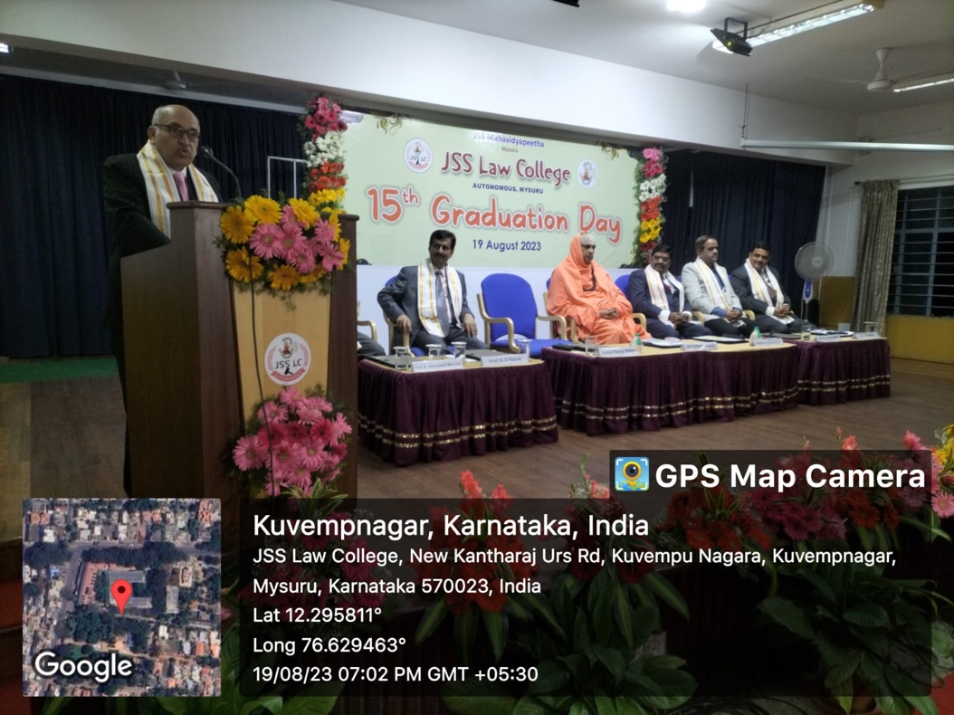
The programme began with an invocation by Miss Likitha. Prof. K.S. Suresh welcomed the gathering. The program was graced by His Holiness Swamiji Jagadguru Sri Sri Shivaratri Deshikendra Mahaswamiji, Suttur Math. Later, the Dr. C.G. Betsurmath, Executive Secretary, JSS Mahavidyapeeta administered the Themisian oath to the students. Honourable Justice Sri Pankaj Mithal, Supreme Court, felicitated the rank holders and Honourable Justice Sri K Somashekar, High Court of Karnataka, distributed the graduation certificates for the students who completed their course successfully. The rank holders expressed their views on this occasion.
HON’BLE SRI JUSTICE PANKAJ MITHAL in his address congratulated the newly passed students and explained the uniqueness of legal fraternity. He also explained the importance of Dharma and reiterated that the balance between Constitution and Sanskriti should always be maintained.
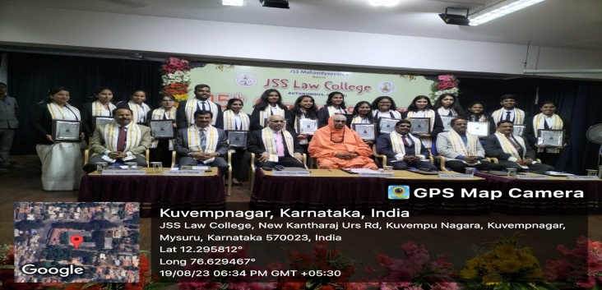
Hon’ble Sri Justice K Somashekar, Chief Guest, addressed the gathering and told them that this day is the testament to their dedication, perseverance and hard work. He further added that the field of law is not confined, and told that the career choice should be resonating with the inner aspirations as each step leads to learning a new and a broader aspect to gain knowledge
After the address by the Chief Guests, His Holiness Swamiji felicitated the Guests of the occasion. The vote of thanks was rendered by Dr. S Nataraju, Principal, and the programme was compered by Sri A T Jagadish.
Parents, students, Advocates, Judges were the stakeholders of this programme.
Independence Day Celebrations:
77th Independence Day Celebration was organized in the College on 15th August 2023. The Chief Guest of the Programme was Dr. Hema Chandra P N Associate Professor in Geography, Post Graduation Department of Geography, Maharani's Arts College Mysuru. The programme was presided by Dr S Natraju Principal and teaching and non teaching staff was present. The Programme was coordinated by Mrs Tejaswini M.

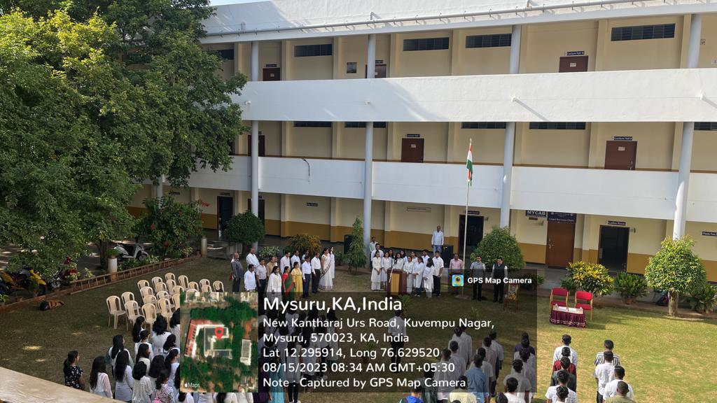
GLOBAL ALUMNI MEET:
Global Alumni Meet was organized on hybrid mode by the JSSLC Alumni Association of JSSLC, on 26th August, 2023, at 11.00am. There were faculty members (teaching and non-teaching) and around 100 alumni present online/offline and express their opinion for the strengthening of the Alumni Association. The programme began with an invocation by Ms. Likitha S Gowda. This was followed by the welcome by Dr. S Nataraju, Principal, JSSLC, Mysuru. Dr. N Vani Shree gave a brief overview about the objectives of the Alumni Association and appealed to the alumni to hand hold in all the activities of the college.
Prof. K S Suresh, Chief Executive, JSSLC, Mysuru, addressed and delivered his presidential remarks and also requested the alumni to support the JSSLC Alumni Association both financially and non-financially in areas of internship, placements, references, visiting the college for delivering talks etc. The alumni had logged in from Kargil, New Delhi, Chennai, Telangana, Kerala, Bengaluru and other places. Most of them gave their valuable input for the growth of the JSSLC Alumni Association through which holistic development of the college was also included. Mr. Pranav Kumar Nair proposed the vote of thanks which was followed by High Tea.

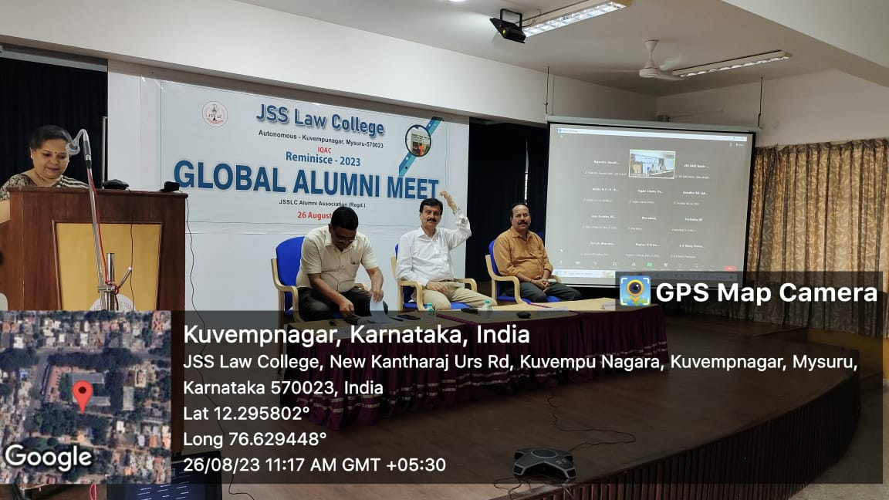

Teacher’s Achievements/Participation:
- Dr. S Nataraju, Principal Participated as Guest speaker in the International Youth Day Celebrations organised by Grassroots Research and Advocacy Movement (GRAAM), Mysuru, in Association with Department of Social Work, MGM University, Mysuru held on 21st August, 2023 at Vigyan Bhawan, UOM, Mysuru.
- Dr. S Nataraju, Principal Participated as resource person in the training programme on “Human Rights in Prison Administration” presented a talk on “International Instruments Specifically Guaranteeing Protection of Human Rights with special reference to Nelson Mandela Rules & Bangkok Rules organised by Prison Training Institute, Mysuru held on 22nd August 2023 at Mysuru.
- Dr. S Nataraju, Principal attended Special meeting on the implementation PMKVY Skill Development Programme held on 30th August 23 at JSSMVP, Mysuru.
- An International paper was presented and published jointly by Asmathunnisa G and Jiban Ann Verghese Titled ‘The Development of Artificial Intellence in Space, Weapon System, and related laws-A coherent Approach, on 24th June 2023, organised by Kerala Law Academy College, Trivandrum, in its 16th International Seminar on ‘Role of International Law in controlling weaponisation and arms race in outer space’.
- A five day training programme was organised by the Prison Staff Training Institute, Department of Prison and Correctional Services, Mysuru, Karnataka on ‘Human Rights in Prison administration, a sponsored programme, Smt Asmathunnisa G, was invited as a resource person and delivered a talk on the topic titled ‘Grievance Redressal mechanism in prison to ensure Human rights of the prisoners’, on 26/08/2023.
- Smt. Sheela Ganesh attended (OFDP) - Fifteen Days Online Refresher Course on Teaching Pedagogy in Legal Studies, Commerce and Social Sciences from 24.7.2023 to 6.8.2023, organised by Guru Angad Dev Teaching Learning Centre, SGTB Khalsa College, University of Delhi.
- Smt. Sheela Ganesh delivered Guest Lecture (online mode) on the topic - 'Environment Protection Act/Rules, 1986', organised by SDM Law College, Mangaluru on 31.8.2023.
- Dr. N Vani Shree has been appointed as Valuer/Examiner for the valuation of answer scripts of II & IV Semester, LL.M (2 Year Course) Examinations of July, 2023, to value Advanced Jurisprudence & Mass Media at University Law College, J B Campus, Bangalore University, Bengaluru-56, on 30th August, 2023.
- Dr. N Vani Shree delivered a talk on the topic “Introduction to International Legal Instruments and their importance”, at the Prison Staff Training Institute, Department of Prisons and Correctional Services, Mysuru, Karnataka, to the participants of A Five Day Training Programme On “Human Rights in Prison Administration”, on 22nd August, 2023, at Prison Staff Training Institute, Mysuru, sponsored by Bureau of Police Research & Development, Ministry of Home Affairs, New Delhi, and organized by Prison Staff Training Institute, Department of Prisons and Correctional Services, Mysuru.
Student’s Achievements/Participation:
- MUN was conducted by Ramaiah Institute of Legal Studies on 3rd and 4th of August 2023, 9 delegates from our college participated by holding various portfolios and 4 students were given certificate of appreciation as (Hon’ble verbal announced on the stage).
- 1st National Moot Court Competition was organised by Kristu Jayanti College of Law, Bengaluru on 17-19 of August 2023, our students name Surya V.Somasundaram VI sem BB.ALL.B ,Hema Patel VIII sem B.A,LL.B and Srinidhi IV sem B.A,LL.B took part and represented our college, they received certificate of participation
- Two days international conference was held at School of Indian Legal thought Mahatma Gandhi University, Kottayam, on Evolving Jurisprudence of freedom as a right in the modern era on 9th and 10th of August, our college students by name Poorna and Surya of VII Sem B.B.A, LL.B presented paper titled ‘A Critical appraisal of the right to reproductive autonomy’.
NCC ACIVITIES:
- Flt Lt. (Dr.) N Vani Shree attended the ANOs/Caretaker Conference in connection with the Annual Training Camp/Enrolment/Training on 1st August, 2023 at the Unit premises of 4 Kar Air Sqn NCC, Mysuru Group, Mysuru. The new Commanding Officer Wg Cdr G S Asish who was to take charge was welcomed by all the ANOs’ and staff.

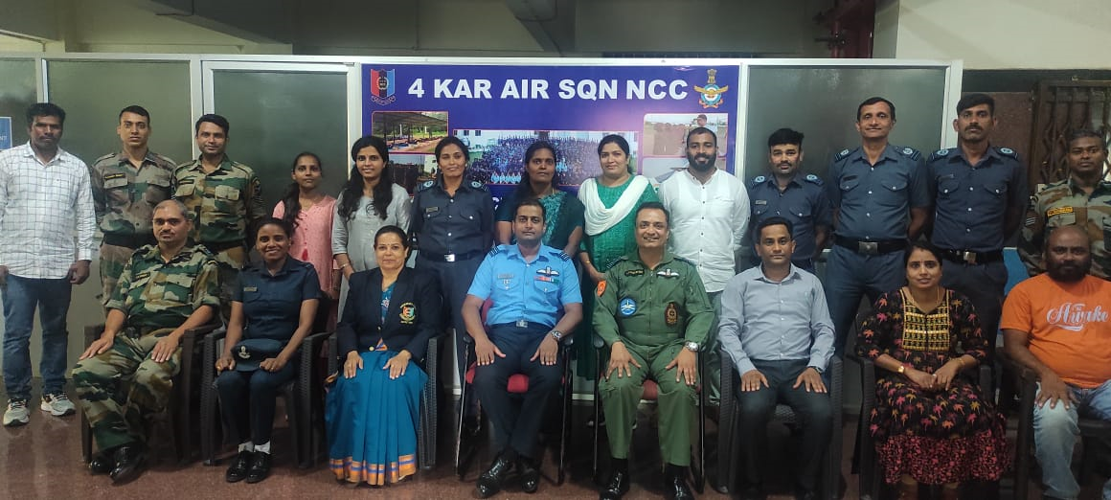
- Flt Lt. (Dr.) N Vani Shree attended a farewell and felicitation programme arranged for Gp Capt. Abhinav Chaturvedi by the Unit 4 Kar Air Sqn NCC, Mysuru Group, Mysuru, on 4th August, 2023, at the Unit Premises. The guests included Air Commodore of Staff Selection Board, Mysuru, Commanding Officer, 3 Kar Navy Unit, Mysuru Group, Mysuru, and other officers. An account of the achievements of the outgoing Commanding Officer was given by the PI staff, ANO and the office staff. The cadets also joined in celebrating CO Sir’s retirement by showering love and affection to him and his family members. There were around 100 as part of the audience including the cadets.
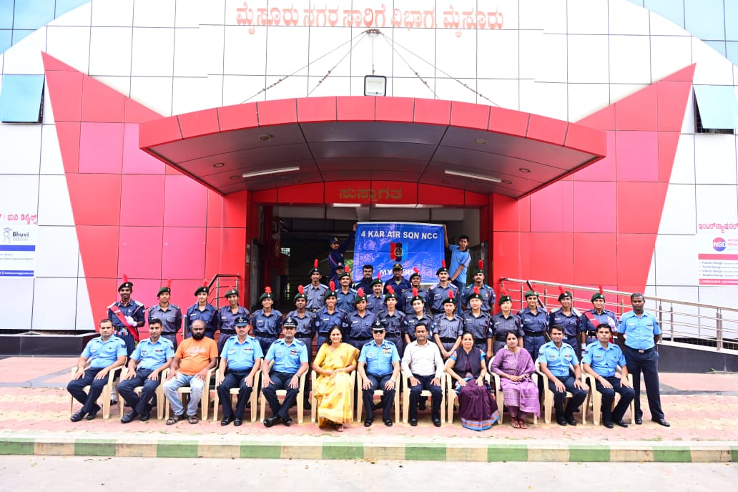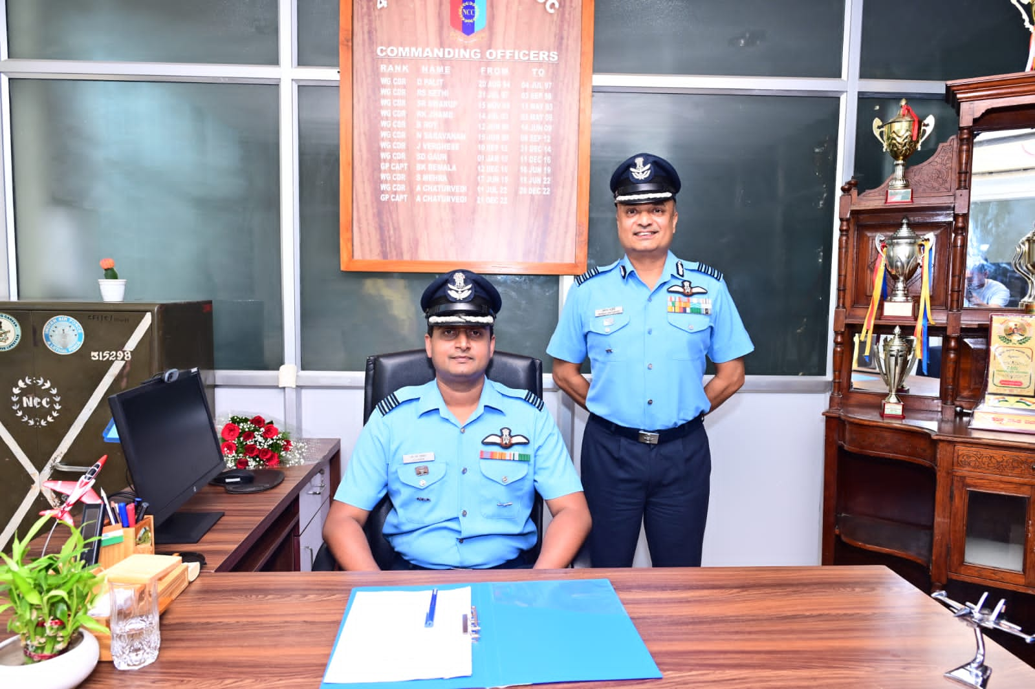
3 Flt Lt. (Dr.) N Vani Shree attended a programme of Farewell given to the Commanding Officer Gp Capt. Abhinav Chaturvedi by the NCC Mysuru Group, Mysuru, on 10th August, 2023, at the NCC Group Headquarters, Mysuru. The Group Commander Col. Nair, other Commanding Officers of Army Units, Navy Unit were present. The NCC Alumni Association members also felicitated the outgoing CO. There were around 200 participants including the cadets.
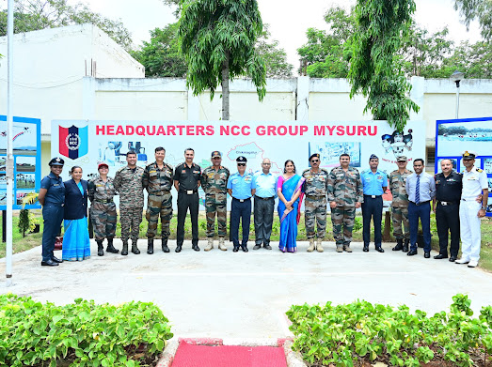
4. IGC (VSC), Camp was held from 11th August to 20th August, 2023, at Belgaum, Karnataka. Vayu Sainik Camp is organized for Air Wing cadets and is attended by 600 cadets from all Directorates. Inter Directorate competitions pertaining to air wing training are held during this camp and after thorough scrutiny and performance of the cadets the final selections are done for the All India Vayu Sainik Camp. Our college Cadets CUO Harsha M V, CWO Jiss Anthony, Cdt Sgt Gowtham M, Cdt Cpl Ganesh Reddy, Cdt Cpl Abhijith Koundinya G R, Cdt Mohammed Subhan, Cdt Veeresh Ittigudi and Cdt Shashank U S attended the camp for further selections.
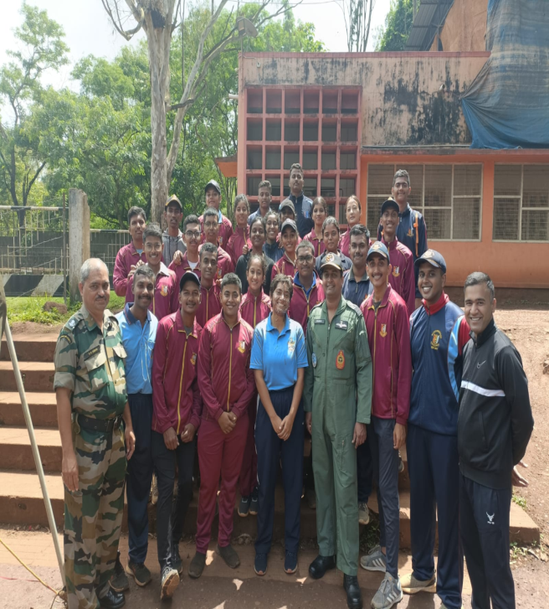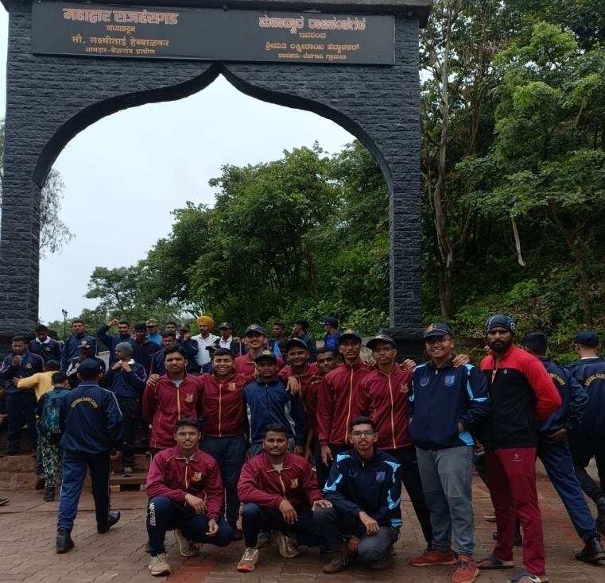

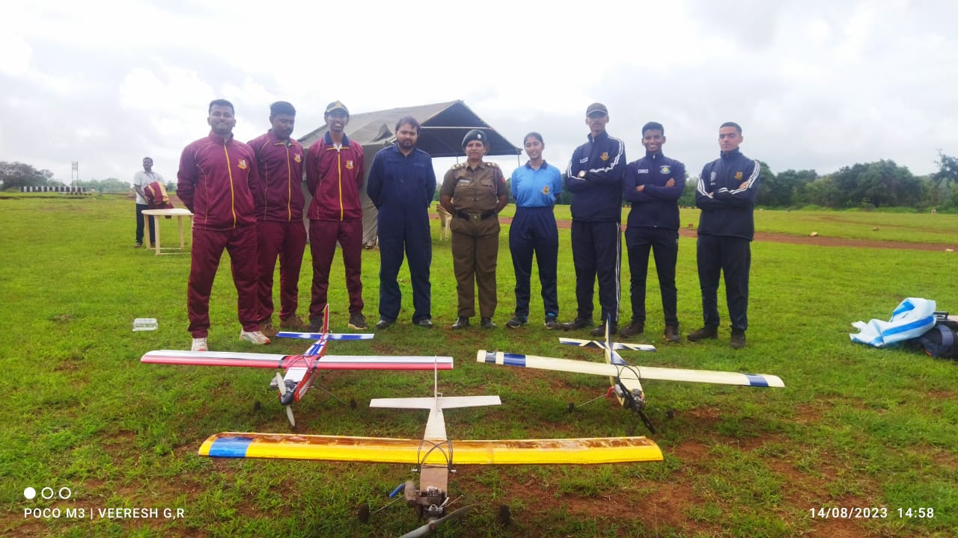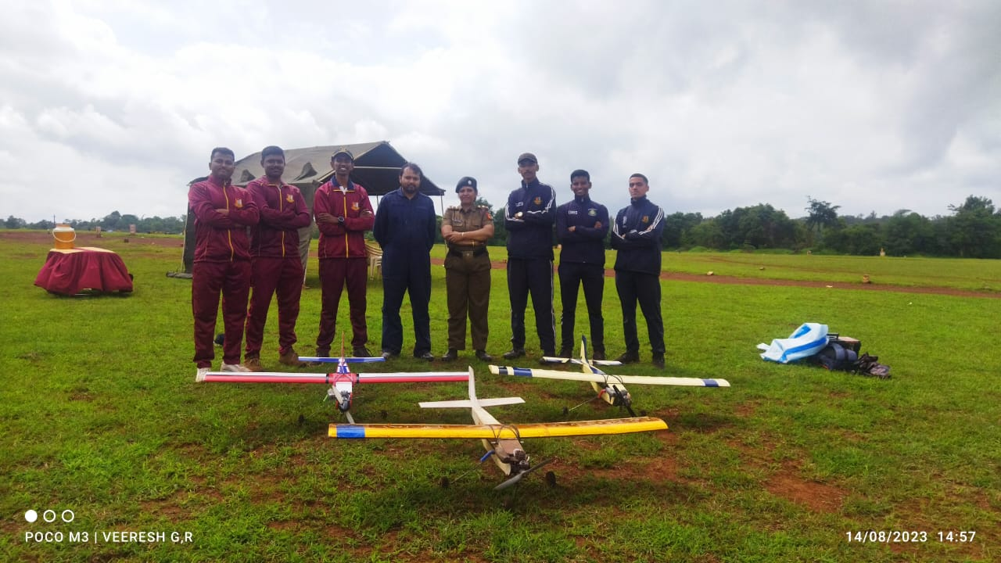

5. Pre-Vayu Sainik Camp – I at Belgaum, Karnataka commenced from 21st August, 2023. Our college cadets CUO Harsha M V, CWO Jiss Anthony, Cdt Sgt Gowtham M and Cdt Cpl Abhijith Koundinya G R were selected to the first level camp. The camp culminated on 30th August, 2023.

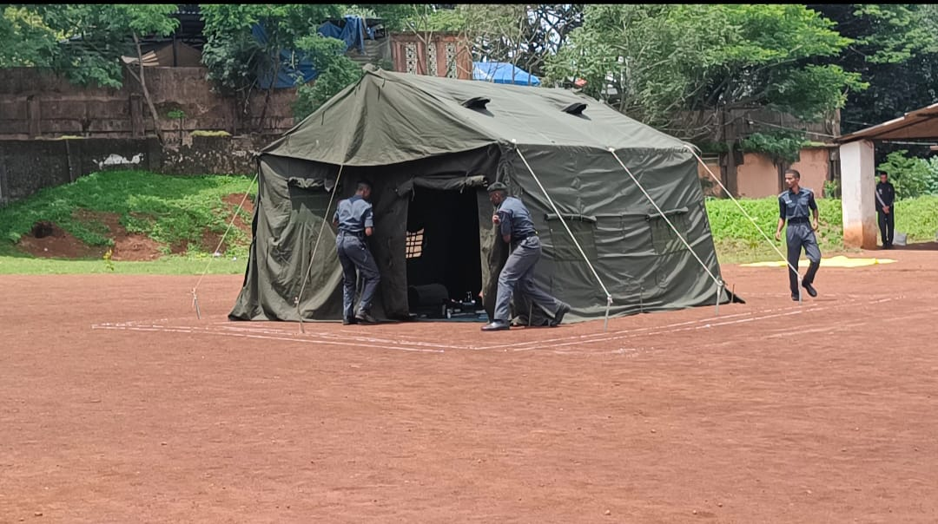
6. Flt Lt. (Dr.) N Vani Shree was detailed as the Coordinating Officer for 77th Independence Day Celebrations at Bannimantap on 15th August 2023. She coordinated and got the 3 contingents of Army, Navy and Air Force ready to march for the Independence Day. The District in charge minister of Mysuru City, and other dignitaries were given the guard of honour by not only the NCC cadets but also by the school students. There were cultural programmes performed by the school children. The Army Contingent got the first prize in the category of March past. There were around 500 participants including the Ministers, VVIPs, VIPs, ANO, School Principals and Staff and the general public.
